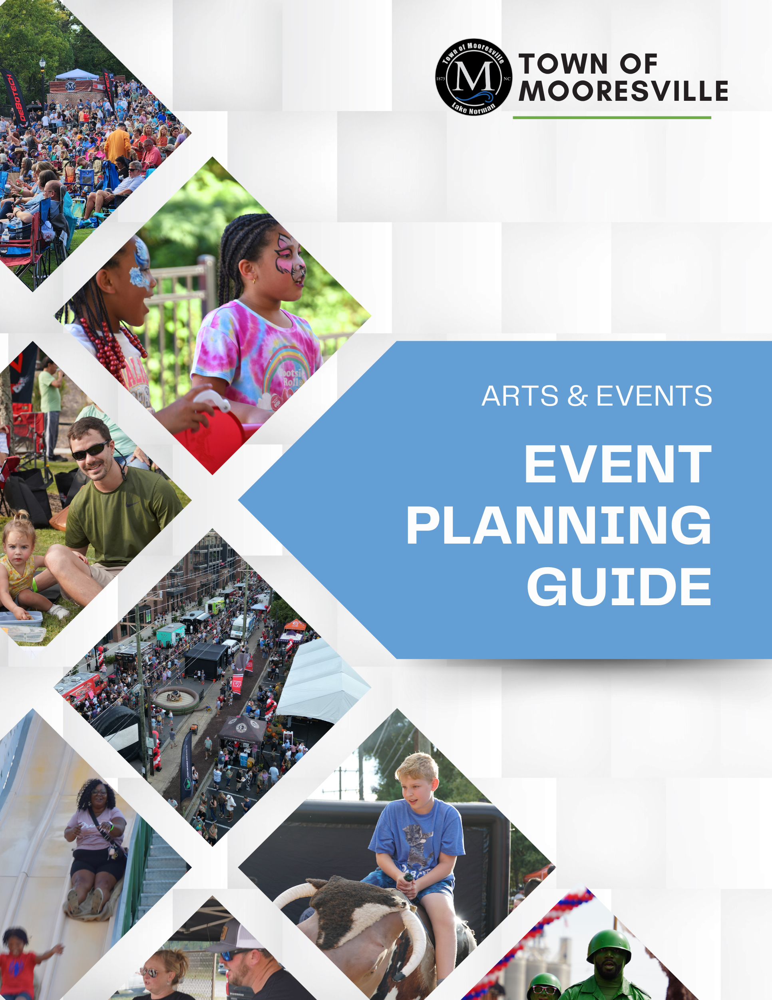
stages
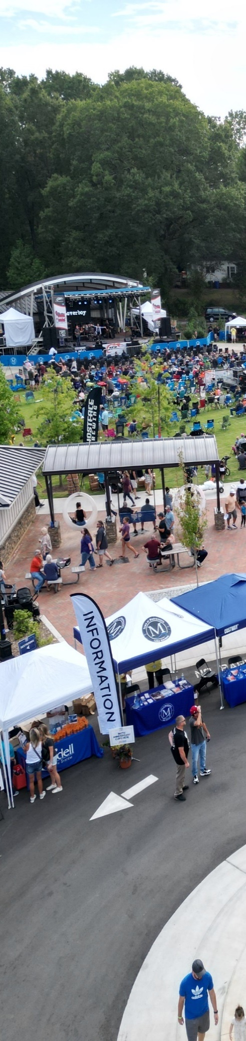

Table of Contents

Introduction 2

Applying for an Event Permit 2
Who needs a special Event Permit 2
Neighborhood Block Parties 2
Definitions 3
Purpose of the Permit Application 5
How to Apply 5
Event Permit Process Overview 6

Fees and Deadlines 6
Special Event Fee Schedule 7
Event Cancellation 8

Event Information 8
Event Information 8
Event Dates and Attendance 9
Event Location 10
Event Details 10

Street Closures 11
Event Street Closure Policy 11

Event Infrastructure and Amenities 14
Stages 14
Tents and Membrane Structures 15
Temporary Structures 16
Electrical/Power Sources 16
Water Use 17
Food 17
Special Event Vendors and Contractors 18
Alcohol 19
Amplified Sound 21
Parking 21
Fencing & Barrier 22
Fireworks/Pyrotechnics 22
Animals 22
Drones 23
Filming/Photography 23
Inflatables,
Amusement Rides/Attractions 24
Emergency Procedures 25
Site Plan/Route Map 26
Security/Safety Plan 27
Medical 27
Transportation 28
Accessibility 29
Waste Management 29
Restrooms/Sinks 30

Moving Events 31

Public Notification 32

Insurance 33
Insurance Requirements 33

Event Evaluation 34
Site Visit 34
Event Performance Evaluation 34
Damages/Outstanding Bills 34
Letter of Intent 34

Town-Supported Events 35

Resource Glossary 38

INTRODUCTION

Welcome to the Town of Mooresville Event Permit Process. The purpose of the Event Planning Guide is to provide Host Organizations with information, policies, and procedures required to successfully navigate the Town of Mooresville’s Event Permit Process. Host Organizations are responsible for all aspects of planning and executing the event. The Town strives to balance the needs of events with the event’s impact on residents and businesses, and as such may require Host Organizations to revise or modify their proposed plans. After reviewing the following information, applicants may begin the Event Application process. Town of Mooresville staff will assist with coordination and approvals throughout the online application. Continue to refer to this document throughout the process of applying. The information provided in this document directly corresponds with the requirements of the application. After you submit your reservation or application, you will be notified if additional information is needed.

APPLYING FOR AN EVENT PERMIT

Welcome to the Town of Mooresville’s Event Planning Guide. This Guide aims to simplify and answer questions that the applicant may have during the permit application process. Event definitions, explanations, and regulations can be found in this guide and in Chapter 20, Article VIII, of the Town of Mooresville Code of Ordinances. It is the Town of Mooresville’s goal to enhance the quality of life and economic prosperity of the community through the support of events while balancing the needs of the residents and business owners affected by these events. While you apply for a permit, town staff is here to help assist you with any questions. Be prepared to obtain the necessary paperwork to streamline the application process.

Who Needs a Special Event Permit?
Special Event Permits are required for events that use public spaces, such as streets, sidewalks, greenways, parks, public squares, and plazas. Special Event Permits are not required for events limited to a Town park shelter rental and that are not open to the public. Events contained to private property only require a Permit when a street closure or a Town event service is requested. There is a separate application process for Block Party Permits, Film Permits, and Pickets/Protests/Demonstrations, for which information can also be found in this Guide. If you are unsure about the application process or whether or not you need a Special Event Permit, please contact the Arts & Events Division for clarification at 704-663-2857.

Neighborhood Block Parties
A Block Party Permit is issued for the closure of a block and/or street for residents of the block and their families. There is no marketing and/or advertising to the general public for the block party and it is not open to the public. The deadline to submit the Block Party Application is 30 days prior to the block party. The Town of Mooresville will accept applications up to one year in advance of an event. The official submission date is the date the completed application is received. There is a separate application process for Neighborhood Block Parties.

Please review the Block Party Planning Guide to be aware of policies, procedures, and important information for having a block party in Mooresville. There is a link to the Block Party Planning Guide on the homepage of the Event website which can be found at https //eventpermits.mooresvillenc.gov.

Definitions
Special Event - A Special Event is defined by the Town of Mooresville as any organized gathering, function, or occasion that takes place on public or private property within the Town limits, is open to the public, and meets one or more of the following criteria:
- Requires significant planning or resources due to size or complexity
- Utilizes Town event services
- Uses public spaces, potentially needing special permits or closures
- Celebrates cultural, artistic, or recreational activities
It is important to note that the definition of a Special Event is broad and inclusive, encompassing a wide range of activities and occasions that contribute to the cultural, social, and economic fabric of Mooresville. Certain expressive activities may not require a Special Event Permit and will be governed by Chapter 16 of the Town Code of Ordinances. Expressive activity shall mean any conduct, the sole or principal object of which is the expression, dissemination, or communication by verbal, visual, literary, or auditory means of opinion, views, or ideas. Expressive activity includes, but is not limited to, protests and pickets. Event organizers are encouraged to consult with the Town of Mooresville's Arts & Events Division to determine if their gathering qualifies as a special event and to obtain guidance on permitting, planning, and logistics to ensure a successful and compliant event.
Private Event - A private event refers to any gathering held on Town property or in Town-managed facilities, such as park shelters, where attendance is restricted to invited guests and not open to the general public. This could include park shelter rentals, social gatherings, weddings, or other gatherings not open to the public. Unlike public events, private events do not go through the Town's formal event permitting process but must still adhere to applicable Town regulations. This may include reservation requirements, payment of usage fees, and compliance with policies regarding noise, alcohol permits, and other facility-specific guidelines.

Permit Fees - Permit Fees are paid by the Host Organization to the Town to cover the cost of issuing, processing, inspecting, and filing the event permit. Permit Fees must be paid at least 14 days prior to the event date.

Additional Expenses and Services - Additional Expenses and Services are paid by the Host Organization to the Town to cover the cost of providing Town event services to create the necessary infrastructure to execute the event.

Application Phase I - Application Phase I will gather general information about the Special Event. The applicant will answer a series of Yes or No questions that determine the scope of the event. Based on the answers provided in Phase I, the application will be customized to the specific needs of your event. This

initial phase of the application does not confirm your ability to host the Special Event. Town staff will check the availability of the requested venue and assess the feasibility of the event.

Application Phase II - Application Phase II will require the applicant to provide more detailed information about the event such as site plans, certificate of insurance, and vendor information. Applicants will only move to Phase II of the application process if Phase I has been approved by Town staff. Phase II of the application shall be completed at least 30 days prior to the event date.

Moving Events (Parades, Races, and Walks) - Moving Events are organized activities that follow a designated course and may involve full or partial closure of Town streets, sidewalks, or greenways. Sometimes Moving Events require a rolling road closure that can be facilitated by the Mooresville Police Department. Races and Walks may involve organized competitive running, walking, or cycling activities that can vary in distance and format. Races and Walks may take place at various locations such as parks, trails, streets, and sidewalks. Races and Walks can vary in distance and format, ranging from short fun runs or walks to longer endurance races such as marathons or triathlons.

Parades may be any public procession or spectacle, often organized for celebration, commemoration, or entertainment purposes. Parades often feature floats, performers, musicians, and participants representing various organizations, communities, or cultural groups.

General Events - General Events are organized activities with a fixed location, often necessitating the closure of roads, public squares, or plazas. They frequently feature amplified noise, food, beverages, merchandise, and various forms of entertainment. Examples include festivals, fairs, performances, rallies, markets, concerts, and similar gatherings.

Neighborhood Block Parties - Neighborhood Block Parties are small-scale, organized activities that close local-service residential streets. These gatherings are initiated by local residents and are intended only for the neighborhood residents and their guests. Neighborhood Block Parties must obtain a Block Party Permit. The Block Party Planning Guide can be found at https://eventpermits.mooresvillenc.gov.

Film Permits - A Film Permit is required for any filming activities on Town property, including public streets, parks, or buildings. This permit ensures that filming complies with Town regulations, maintains public safety, and minimizes disruptions to the community. To obtain a film permit, applicants must provide details such as the filming location, dates, and crew size. The Film Planning Guide can be found at https://eventpermits.mooresvillenc.gov.

Special Events Committee - The Special Events Committee is responsible for the review and evaluation of all Special Event Permit Applications and Street Closure requests within the Town of Mooresville. This
committee ensures that proposed events align with town policies, meet safety and logistical standards, and consider the impact on the community. The committee consists of Town staff members from various Town departments such as Arts & Events, Mooresville Police Department, Mooresville Fire-Rescue,
Sanitation and other affected departments to assess the feasibility of each event, offering guidance to Host Organizations on compliance with regulations.

Host Organization - The Host Organization is the applicant and bears legal and financial responsibility for the Special Event and all associated activities. The Host Organization can take various forms, such as a non-profit tax-exempt entity, a commercial enterprise, or an individual. If the Host Organization holds a 501(c) tax-exempt status, inclusion of its IRS Tax Exemption Letter is required as part of the permit application process. Non-profit organizations should be duly registered as such with the North Carolina Secretary of State or with the Secretary of State from which state they reside.

Chief Officer of the Host Organization - The Chief Officer of the Host Organization, whether it is the President, Executive Director, or another authorized officer, must possess the authority to make planning, operational, financial, and other legally binding decisions on behalf of the Host Organization.

Billing Contact - The Host Organization maintains ultimate liability for payment of all fees and costs assessed by the Town of Mooresville. The Town will send invoices to the address listed for the Host Organization unless an alternate billing address is provided.

Primary Contact - The Primary Contact serves as the official representative of the Host Organization and collaborates closely with the Town. They must possess the authority to make planning, operational, financial, and other legally binding decisions on behalf of the Host Organization.
If the Primary Contact is a volunteer of the Host Organization or a Professional Service Provider/Event Organizer hired by the Host Organization, the Chief Officer must provide a letter authorizing the Primary Contact to act on behalf of the Host Organization as part of the permit application.

Onsite Contact - The Onsite Contact serves as the primary point of contact during the event. The Onsite Contact must provide his or her contact information, including mobile phone number. The Onsite Contact must be available in person or by phone during all phases of the event including set-up, event hours, and tear-down.

Purpose of the Special Event Permit Application
The purpose of the Town of Mooresville's Special Event Permit Application process is to ensure the safety, compliance, and orderly conduct of Special Events and activities within Town limits. It also serves as a communication method for various departments that are involved in the Event Permitting Process and enables the Town to provide the necessary infrastructure for Special Events.

How to Apply
- Submit an event application online at https //eventpermits.mooresvillenc.gov.
- Once your Phase I application has been received, staff will review it to determine the feasibility of your event and contact you within 7 business days to discuss the next steps in the process. If your event is approved to move to phase II of the application process, you will be prompted to
complete the Phase II portion of the application. (*Phase I only applies to Special Event Permit applications)
- All necessary documentation required in the Phase II portion of the application including site plans, insurance certificates, and vendor information, must be completed by the designated

deadlines thirty days prior to the event date. The Town will then contact you with instructions on how to proceed with the Permit Fee payment.
- Submit the corresponding Permit Fee at least 14 days prior to the event date. (*Block Party Permit Fees must be paid 7 days in advance)
- A Special Event Permit will be issued once all requirements have been met.
NOTE: APPLYING FOR A SPECIAL EVENT PERMIT DOES NOT GUARANTEE THAT YOUR EVENT WILL BE APPROVED.

Special Event Permit Process Overview

FEES AND DEADLINES

The deadline for submitting a Special Event Application is at least 90 days prior to your intended event. All required documentation (ex. Certificates of Insurance, Site Maps, or other relevant documents) must be submitted at least 30 days prior to the event date. A Permit will not be issued for an event until all Permit Fees have been paid. Permit Fees must be received at least 14 days prior to the event date.

The deadline for submitting a Block Party Permit Application is at least 30 days prior to the event date. All Permit Fees must be paid at least 7 days prior to the event date. See the Block Party Planning Guide for more information.

Event Fee Schedule
Event Type | Application Deadline | Permit Fee  Non-Profit | Permit Fee  For Profit
Moving Event (Parade/Race/Walk) | 90 Days | $100 | $125
General Event (1,000 people or less) | 90 Days | $125 | $150
General Event (More than 1,000 people) | 90 Day | $175 | $200
Neighborhood Block Party | 30 Days | $50 | N/A

Additional Expenses and Service Fees
Other Expense | Cost | Agency | Payment Deadline
Off-Duty Police Officer | $40/hour per officer | Mooresville Police Department | 14 Days
Off-Duty Police Officer (Supervisor) | $50/hour per officer | Mooresville Police Department | 14 Days
Police Vehicle | $25/Vehicle | Mooresville Police Department | 14 Days
Mooresville Fire-Rescue Personnel | $35/hour per officer | Mooresville Fire-Rescue | 14 Days
MFR On-Site Cooking Inspection | $20 | Mooresville Fire-Rescue | 14 Days
MFR Tent/Inflatable Inspection | $20 | Mooresville Fire-Rescue | 14 Days
MFR Pyrotechnics Inspection | $200 | Mooresville Fire-Rescue | 14 Days
Waste Management | $30/hour per staff member | Mooresville Public Ops | 14 Days
Waste Receptacles | $5/can | Mooresville Public Ops | 14 Days
Street Closure Fee | $100-$1,000 | Arts & Events | 14 Days
Cancellation Fee | $50 | Arts & Events | N/A
Late Fee | $50 | Arts & Events | N/A
All staffing levels for Town of Mooresville services are determined by the Town of Mooresville during the Phase II portion of the Special Event Permit Application process. The Permit Fees are applied based on the duration of the permit.

Event Cancellation
Special Events may be canceled up to 14 days prior to the event date without penalty. Special Events canceled after this deadline will forfeit 100% of the Permit Fees.

In the case of impending inclement weather, an event may be rescheduled up to 2 days before the event with no penalties. If the event is rescheduled less than 2 days before the event, a fee of $50 will apply. Rescheduled days will be subject to availability. If a determination is made to cancel the event due to inclement weather less than 14 days in advance, all permit fees will be forfeited. Fees for additional services may be refunded.

Block Parties may be canceled up to 3 days prior to the event date to receive a full refund of Permit Fees. Block Parties may be rescheduled up to 24 hours in advance due to inclement weather. If the event is rescheduled less than 24 hours before the event, a fee of $50 will apply. A Rain Date must be listed on the Resident Survey at the time of obtaining signatures to be eligible for rescheduling.

EVENT INFORMATION

Event Information
The Host Organization will be required to provide an overview of the proposed event. The Town of Mooresville may use this information for promotional purposes, including on the Town of Mooresville's Calendar of Special Events, social, and print media. You will be asked for a more detailed description of your event operational plans in Phase II of the permit application.

If your proposed event plans incorporate two or more distinct event types that may be best reviewed and managed as separate events, such as a parade with a separate or multi-day festival or a marathon with a separate 5k route, the Town may require separate permit applications for the specific event types.

Similarly, if you propose to host a multi-day event where the event plans vary significantly from day to day, such as a different venue design or the change in designation from an all age no alcohol venue to a venue with alcohol service, you also may be required to submit separate applications to ensure the proper review of each proposed element.

Admission Based Events
Town of Mooresville parks, streets, and other public property are intended to be open to the community. When an event charges admission to use public property, additional permitting fees may apply. Some areas of public property may not be available to restrict access to the public. The primary charged admission types are:
- Tickets/General Admission Fee - An event that restricts access to public property. Attendees are required to pay admission to enter the property.
- Registration Fee/Donations - An event that charges fees or collects donations for participating in an organized moving event. Spectators and the general public may still visit public property.

- Exclusive Access Area - An event that has an isolated section of public property that requires admission to access. Examples include a VIP tent or beer garden.

Event Dates & Attendance
The Special Event Permit will be limited to the date(s) and time(s) provided for the set-up, event duration, and tear-down of the proposed event. Set-up begins on the date and time the first piece
of equipment is scheduled to arrive at the venue and/or when the venue is scheduled to limit public access for set-up purposes. Tear down ends on the date and time all equipment has been removed from the venue, the venue is clean, and the area has been opened for use by the public. Your insurance must cover all timeframes from set-up to tear-down. Events may be Single-day, Multi-day, or Recurring.
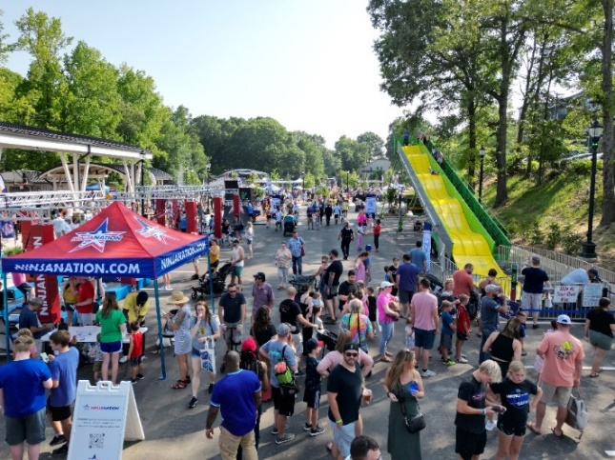
Single-Day Event
Everything for the event takes place within the span of a single calendar day. There can be no set-up or tear-down before or after the day selected.

Multi-Day Event
The event timeframe, including set-up, event duration, or tear-down, exceeds a single calendar day. For example, set-up begins on Friday, the event takes place on Saturday and tear-down finishes on Sunday.

Recurring Event
The event takes place on a specific day multiple times a year. For example, a street fair that occurs monthly.

Anticipated Daily Total Attendance
Understanding the total anticipated number of attendees/participants for a given day helps the Town of Mooresville to evaluate the permit application plans and staffing needs.

Anticipated Daily Peak Attendance
Anticipated Daily Peak Attendance is the number of participants/attendees at the highest point on a given day. For example, a festival may anticipate 25,000 attendees over the course of a day with a peak attendance of 10,000 people.

Anticipated Daily Peak Hours
The start and end times identified for peak hours should correspond with the peak attendance. For example, a festival may be scheduled to take place from 10 a.m. to 10 p.m. with an anticipated peak attendance of 10,000 attendees from 6 p.m. to 10 p.m.

Rain Dates
The availability of public property and Town support services are coordinated through the application process. Special Events are only permitted for the dates required for set-up, tear down, and event day
logistics. Rain dates are not held for events in the event of inclement weather. The applicant must indicate all the dates needed for the event.

In the case of impending inclement weather, an event may be rescheduled up to 2 days before the event with no penalties. If the event is rescheduled less than 2 days before the event, a fee of $50 will apply.
Rescheduled days will be subject to availability. Rescheduled events must take place within 12 months of the originally scheduled date. If a determination is made to cancel the event due to inclement weather less than 14 days in advance, all permit fees will be forfeited. Fees for additional services may be refunded.

Event Location
The Town of Mooresville requires detailed information regarding the Special Event venue.

Event Venue Type
This is the type of property that will be used for the event venue. Some events may use multiple property types. For example, a park and a public street.

Event Venue Description
This is a narrative of the entire proposed event venue to assist the Town in better understanding the scope of the proposed venue. This should include event areas as well as areas that may not be open to the public such as a staging or production area.

Event Venue Address
This is the street address that can be considered the primary location or entrance of the event. The information may be used by the Town to provide a calendar, online mapping, traffic, and driving instructions. If the event is on a street, please list each road closure from intersection to intersection.

Event Details
Applicants will need to share the scope of event components by answering a series of “Yes or No” questions. During the review of the application, the Town of Mooresville staff will be able to determine if the location requested is available and appropriate based on the overview of these details. Supplemental details will need to be submitted for every answer of “Yes” on the application. While the application is in draft form, the applicant may change an answer in the Event Details section as planning evolves. The application will automatically adjust based on the information provided in this section. Applicants will only need to provide details that correspond directly with the event components. Events with more components will have to complete additional sections of the application, but less complex events will have fewer sections to complete.

STREET CLOSURES

Host Organizations that would like to request a street closure must meet the eligibility and criteria outlined in the Town of Mooresville’s Street Closure Policy below. Street Closures will be evaluated in Phase I of the event permit application process to determine feasibility.

Event Street Closure Policy
Applicants seeking street closures for events and filming must provide detailed information on areas they request to close including impact to any public right-of-way, street, alley, path, or sidewalk. Street
closures will be reviewed for public safety, traffic flow, and impact to any surrounding neighborhoods and/or businesses.

Application Process
Application Submission: If an Event Organizer seeks to close one or more streets for their Event, the Event organizer must complete a Special Event Request, Block Party Permit Application, or Film Permit Application, whichever may be applicable. The application/request must include the event name, date, and time, proposed street(s) for closure, event description and purpose, expected attendance, and contact information.
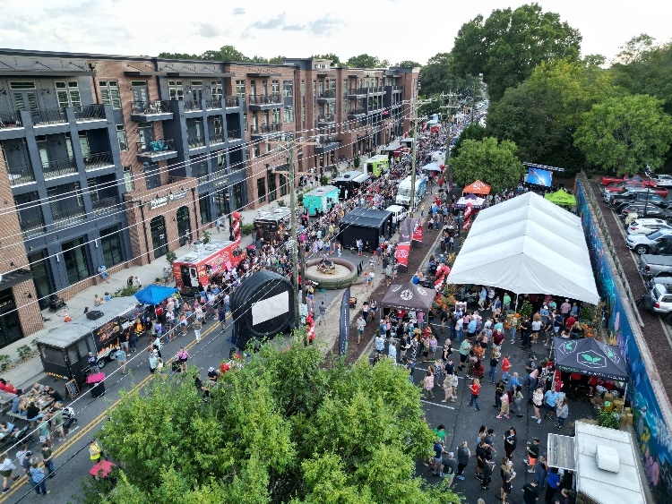
Types of Events Eligible for Street Closures
National Holidays, Anniversaries, Remembrance Days: Street closures will be considered for events that celebrate national holidays (e.g., Independence Day, Memorial Day), remembrance days (e.g., Veterans Day, Martin Luther King Jr. Day), and anniversaries.

Community Events: Events that promote community engagement and local culture (e.g., festivals, street fairs, block parties, and moving events like races, walks, and parades) are eligible for street closures. (NOTE: Block Parties must obtain signature approvals from at least 80% of residents in the neighborhood)

Filming: Street closures for filming will be considered for organizations that meet Town requirements and guidelines. (NOTE: Film crews must obtain signature approvals from at least 80% of residents from predominantly residential neighborhoods.)

Special Considerations: The Town may consider other events for street closures on a case-by-case basis, particularly those that have significant cultural, historical, or social importance to the community and/or generate tourism.

Application Deadlines: Applications must be submitted by the applicable deadline specified below to ensure sufficient time to process. Applicants requesting to close state-maintained streets should submit their applicable application as early as possible but no later than 90 days prior to the requested closure. Only the North Carolina Department of Transportation (NCDOT) has the authority to close state-maintained streets within the Town. The Town cannot guarantee the timeframe in which NCDOT will review and process street closure applications. The Town cannot guarantee that applications submitted after the applicable deadlines will be processed prior to the requested closure date.
- Special Event Street Closure Deadline: 90 Days
- Block Party Street Closure Deadline: 30 Days
- Film Permit Street Closure Deadline: 14 Days (*Some exceptions may be allowed but streets managed by NCDOT will take longer.)

Application Review: Special Event applications will be reviewed by the Town of Mooresville Special Events Committee, which includes representatives from the Arts & Events Department, Police Department, Fire Department and Sanitation, and Traffic/Transportation. Block Party Applications and Film Permit Applications will be reviewed by Town staff.

Approval Criteria: The following criteria will be considered during the review process:
- Impact on traffic flow and public safety, including the general flow of traffic expected at the time of the proposed event, whether the event will significantly affect the Town’s ability to deliver police, fire, and medical emergency services to the event or in the vicinity of the event, and the existence, if any, of alternative routes for traffic flow
- Potential disruption to businesses and residences, taking into consideration the timing and duration of closure, location, date, whether the event will include amplified music, etc.
- The history of the applicant or proposed site for similar events where there were traffic control problems, littering, and trash removal problems, noise or other disruptions associated with the event
- Economic benefits to the community
- Historical significance or relevance of the event (e.g., national holidays, remembrance days, anniversaries, etc.)
- Special Events must be free and open to the public

Main Street Criteria: In addition to the above criteria, the following criteria will be considered during the review process for Main Street Closure Requests:
- Event attendance
- Event’s potential to attract visitors and create a positive economic impact
- Event’s compatibility with the surrounding area/neighborhoods
- Frequency and length of Special Events may be a factor and affect the ability to host your event

Alternative Venues: If the street closure application does not meet the above criteria, the Town may provide guidance and assistance in identifying suitable alternative locations for the event. This may include parks, plazas, or other streets capable of hosting the Special Event.

Street Closure Conditions
Minimizing Impact on Businesses: Efforts will be made to minimize the impact on downtown businesses. This includes:
- Scheduling street closures outside of peak business hours whenever possible
- Scheduling street closures only for the minimum duration needed to ensure a safe and successful event
- Providing clear signage and alternate routes for vehicular and pedestrian traffic
- Applicants notifying affected businesses at least 30 days in advance of the closure

Public Safety, Traffic Management and Event Support: The Town of Mooresville will coordinate with other Town departments to ensure:
- Adequate safety measures are in place (e.g., barricades, signage, police presence, if applicable)
- Efficient traffic management and access for emergency vehicles
- Coordination of additional trash and recycling services if necessary

The Event Organizers will be responsible for all fees associated with any additional support services provided by the Town in accordance with the applicable fee schedule.

Communication and Notifications
Public Notification: The Town will ensure that residents and businesses are informed about upcoming street closures through various channels, including email. Event organizers are required to collaborate closely with the Town of Mooresville, local businesses, residents, and stakeholders to communicate street closure information.

Street Closure Signs: The Town requires posted signage communicating street closure times at least 48 hours prior to the scheduled street closure.

Safety & Logistics
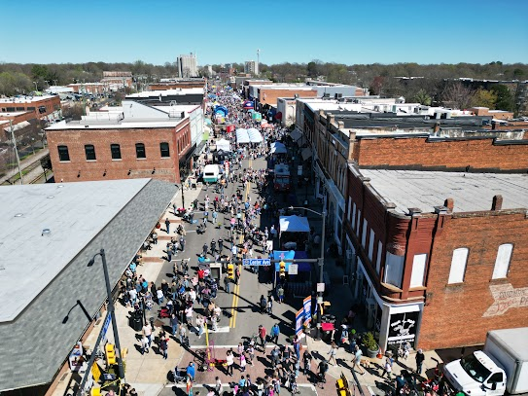
Safety & Equipment: Street closures will only be approved for events that can be managed and coordinated to ensure the safety of attendees and participants. All approved street closures will require applicants to obtain traffic/safety equipment for the safe closure of these streets and to ensure proper detour and parking information is posted. If a street closure is granted, a street closure gives the applicant use of the streets within the areas designated by the permit. Typically (but not always) this will include access to all parking spaces within the closed right-of-way as well. A 20-foot-wide emergency access lane is required throughout the event site. Additionally, the North Carolina Fire Prevention Code requires that fire hydrants have a minimum clearance of 3

feet on all sides of the hydrant. Closures of state-owned streets require NCDOT consultation and approval, which may increase the amount of time needed for approval. Pedestrian and handicapped access must be maintained on public sidewalks and trails throughout the event area, course, or route. Events involving the closure or obstruction of a public right-of-way will require safety barricades, variable message boards, and/or hiring of off-duty police officers. The number and placement of barricades is determined by Town of Mooresville staff. This is a critical measure and is strictly enforced to help ensure public health and safety at Special Events. Additional fees will apply for the use or rental of safety equipment and/or staff.

Timing and Duration: If a street closure is granted, the closure will only be granted for a specific time period deemed necessary for the event. This time period considers event setup, duration, and breakdown. The duration of street closures should be minimized to mitigate inconvenience to affected businesses, patrons, residents, and vehicular traffic.

The street closure policy will be reviewed annually to ensure it continues to meet the needs of the community and supports Mooresville as an event-friendly town, while helping to minimize the negative impact to downtown businesses and Town residents. By following this policy, we aim to create a
a balanced approach that promotes a vibrant, safe, and event-friendly environment for all residents and visitors.

EVENT INFRASTRUCTURE & AMENITIES

The scope of the applicant’s event will be determined based on the information provided in Phase I of the application process. Phase II of the application will require the applicant to provide more detailed
information about the event such as site plans, certificate of insurance and vendor information. If the Host Organization plans to provide certain elements at the event such as staging, tents and food vendors, information regarding the Town of Mooresville’s policy can be found in this section of the Event Planning Guide. Multiple Town of Mooresville departments including Police, Fire, Building/Permitting,
Sanitation and Risk Management are involved in the final approval process of the event. If you have any questions throughout the process, please reach out to the Event Permit Coordinator at (704) 662-7955.

Stages
If your event requires staging, there are certain safety protocols that may need to be followed. If you are including staging at your event, there are a variety of requirements. Most Special Events use standard-sized portable, mobile/trailer, or riser/platform stages. (Some parks and public spaces have a permanent performance area.)

Stages 30" or Lower
If you propose to use a stage that is 30" or lower in height and there are no plans to place temporary built components, including trusses or tenting on the stage, additional review and inspection is not required.

Stages Greater than 30"
If you propose to use stages where the finished floor is more than thirty inches above the lowest adjacent grade or floor, a permit or additional review is required. The additional review and requirements may take the form of a self-certification and inspection process or issuance of a Building Permit instead of, or in conjunction with, the self-certification process.

Stages with Temporary Built Components
For any stage, if you propose to incorporate elements such as footings or a foundation that is affixed to the ground, elevated platforms, walkways, tents, trusses, seating areas, or plan to make the stage
accessible to the general public, additional permitting and inspection will be required. The additional review and requirements may take the form of a self-certification and inspection process or issuance of a Building Permit instead of, or in conjunction with, the self-certification process.

Mobile/Trailer Stages
If you propose to use mobile staging units or a portable trailer stage where the stage remains affixed to the wheels of the vehicle and a valid state-issued license plate is affixed to the vehicle, additional permitting or inspection is not required, unless temporary built components are added to the stage.

Tents and Membrane Structures
Many events use several different tents, canopies, and other membrane structures throughout the venue to support a wide variety of public activities. Whether provided by the Host Organization or
vendors, all tents, canopies, or membrane structures that are part of the Special Event, and any production or support areas, must comply with all provisions of the North Carolina Fire Code.

Estimation
Provide the estimated number and sizes of tents, canopies, and membrane structures to understand the event's scale.

Provision
Identify if tents, canopies, and/or membrane structures are provided by the Host Organization, in combination with vendors, or solely by vendors.

Flame Resistance
Flame Resistance material is required for canopies larger than 400 square feet and tents larger than 800 square feet per the North Carolina Fire Code. Temporary membrane structures or tents shall have a permanently affixed label bearing the identification of size and fabric or material type. Cooking under a tent is prohibited at a Special Event.

Placement
Open flames, devices emitting flame, fire, heat, or any flammable or combustible liquid, gas, or charcoal, other cooking devices, and other unapproved devices shall not be permitted inside or located within 20

feet (6096 mm) of the tent or membrane structure while open to the public unless approved by the fire code official. During Special Events utilizing street closures, a space of at least 20 feet wide within the event area must be kept open during the closure for emergency vehicle access.

Review and Inspection
If the aggregate square footage of the tents used in your venue is greater than 800 square feet, any portions of the tent are not directly attached to the ground, any portions of the tent are located near on-site cooking, or if the tents or placements thereof have other unique conditions, additional permits and inspections from the Fire Department may be required.

Temporary Structures
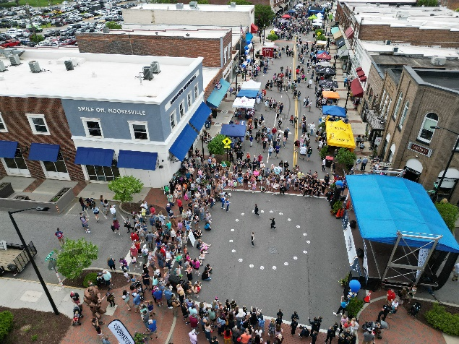
Some Special Events may require temporary structures including but not limited to stage areas, major entrances, signage, sound and lighting platforms, or other specialized elements, as well as some tent structures. Any temporary structure will be subject to inspection by the Town of Mooresville. Additionally, platforms, walkways, seating areas, and stages may also be subject to review and inspection. Please ensure that proper plans and drawings are submitted during your application process. Depending on the complexity of the temporary structure, it may require a building permit.

Electrical/Power Sources
Event planning often involves the logistical challenge of providing adequate electrical power. To meet this need, Host Organizations are required to supply their own generators and power sources for lighting, sound systems, and vendor booths. While the Town of Mooresville recognizes the potential
noise and environmental impacts of generators, we encourage the use of models that minimize these effects. This approach aims to create an enjoyable and healthier atmosphere for event attendees.

Electrical Use
Host Organizations are prohibited from utilizing any of the Town of Mooresville's electrical outlets or power sources for their events without securing permission from Town of Mooresville staff. All Host Organizations are required to supply their own generators and sources of power to meet the electrical
needs of their events. This includes, but is not limited to, lighting, sound systems, vendor booths, and any other electrical equipment necessary for the event.

Event Safety
The installation of all electrical elements must comply with the North Carolina Fire Code as adopted by the Town and all other applicable articles of the North Carolina Electrical Code. All wiring, equipment, and devices must be maintained in a safe working condition for the duration of your event including set-up and dismantling. Host Organizations are responsible for implementing appropriate safety measures to prevent electrical hazards during the event. This includes proper grounding of generators, securing

power cables with cable ramps to prevent tripping hazards, rubberized mats and/or cord covers, and ensuring that electrical equipment is installed and operated by qualified, licensed professionals. Generators may not be placed inside tents or structures of any kind and must be kept at a safe distance from these structures to prevent fire or carbon monoxide hazards.

Notification Requirements
Event organizers must notify the Town of Mooresville of their intention to use generators or external power sources at least 30 days prior to the event date. Failure to provide timely notification may result in the denial of the use of external power sources.

Inspection
The Fire Marshal or other Town representative may inspect power distribution safety at your event to ensure the safe use of electrical and power supply within the venue and may require onsite modifications.

Water Use
Host Organizations are strictly prohibited from using any Town of Mooresville public water access areas, including hydrants, spigots, or other public water sources, for event purposes. Utilizing public water access without prior authorization from the Town of Mooresville is illegal and subject to enforcement actions. Host Organizations must plan for alternative water resources as part of their event logistics.
If water access is essential for your event, please coordinate with private vendors or water services to ensure compliance with local ordinances. Failure to adhere to these regulations may result in fines or additional restrictions on future event applications.

Food
Organizing an event involving food requires adherence to strict regulations for safety and hygiene. Below is information regarding obtaining permits for food-related activities at your event.

Host Organization Responsibility
The Host Organization must complete the Iredell County Health Department Event Coordinator Application at least 15 days prior to the event date for any events where food will be served or sold.
- The Event Coordinator Application can be found here: https://www.iredellcountync.gov/DocumentCenter/View/235/Application-for-Event-Coordinator-and-Requirements-PDF?bidId=

If vendors will be selling food at the Special Event, a Temporary Food Establishment permit from the Iredell County Health Department may be required for each vendor.
- The Temporary Food Establishment Application can be found here: https://www.iredellcountync.gov/DocumentCenter/View/231/Application-for-Temporary-Food-Service-Establishment-TFE-Permit-PDF

The Host Organization is solely responsible for verifying appropriate permits on behalf of any food vendors they are allowing at the event. Proof of issuance of health department permits may be required before receiving a Special Event Permit.

Iredell County requirements are subject to change pursuant to amendments made by Iredell County. It is the Host Organization’s responsibility to ensure that all county requirements are met by each vendor.

Individual Vendor Responsibility
It is the responsibility of the vendor to ensure compliance with regulations. All food and beverage vendors should obtain proper permissions from the Iredell County Health Department. Additionally, food trucks and mobile food establishments must adhere to county health department requirements and may need to complete the Temporary Food Establishment Application.
All food trucks and mobile food establishments must adhere to all state and Iredell County Health Department requirements.
- A checklist can be found here: https://www.iredellcountync.gov/DocumentCenter/View/11510/MFU-518

Open Flame Cooking
Vendors using open-flame cooking devices must comply with the North Carolina Fire Code and all Iredell County food handling and inspection requirements. Vendors may be subject to inspection by the Fire Marshal.

Permit Information
Additional information about Iredell County rules and regulations pertaining to food and beverage handling can be obtained on the Iredell County Health Department website:
https://www.iredellcountync.gov/854/Food-Protection-and-Facilities

Special Event Vendors and Contractors
A Host Organization may use vendors and/or contractors to provide services or amenities for the Special Event.

A Special Event Vendor is defined as a vendor who establishes a booth or occupies a designated space at a Special Event to sell or distribute goods and/or services.

A Special Event Contractor is defined as a professional or a company that provides specialized services for various types of Special Events. For example, a Host Organization may hire a company to operate rides or attractions or a company to provide portable restrooms.

Special Event Vendor Requirements
Below are guidelines for Special Event Vendors.

Vendor Registration
It is required that all vendors register with the Host Organization before the event. Additionally, the Host Organization must submit a complete list of all participating vendors no later than 30 days prior to the event. The list of vendors must include:
- Name of the vendor
- Contact information (phone number, email address)
- Type of merchandise sold, or services offered

Vendor Placement
Placement and setup of vendor booths are determined through collaboration between the Host Organization and the Town of Mooresville. Vendor placement should be identified on the Special Event Site Plan. Vendors are required to adhere strictly to designated set-up times and locations, as well as comply with any instructions provided by event organizers or Town officials. This ensures a smooth and organized set-up process that aligns with the event's logistical requirements and regulatory considerations.

Special Event Contractors
Below are guidelines for Special Event Contractors.

Special Event Contractor Requirements
It is mandatory for the Host Organization to enter into a contract with all Special Event Contractors. The Host Organization is required to ensure that all Special Event Contractors have proper insurance requirements and meet all state guidelines. Special Event Contractors may need to provide proof of liability insurance as required by the Town of Mooresville or the Host Organization. The Host Organization must provide a detailed list of all contractors no later than 30 days prior to the event date.

Compliance with Regulations-Vendors/Contractors
Vendors and contractors are expected to comply with all regulations and guidelines set forth by the Town of Mooresville, encompassing zoning ordinances, health and safety standards, and licensing
requirements. Failure to adhere to these regulations may lead to penalties, fines, or expulsion from the event. It is imperative for vendors and contractors to ensure full compliance to avoid any adverse consequences.

Clean-Up and Departure-Special Event Vendors/Contractors
Vendors and contractors bear the responsibility of cleaning their designated area at the conclusion of the event, ensuring that no debris or waste is left behind. Failure to perform this task adequately may lead to penalties or exclusion from future events. It is essential for vendors and contractors to fulfill this obligation to maintain the cleanliness and integrity of the event space, fostering a positive environment for attendees and future events.

Alcohol
The consumption of alcoholic beverages may be permitted provided that the Host Organization complies with all North Carolina Alcoholic Beverage Control Commission (ABC) licensing and permitting

requirements. Having alcohol at your event will result in additional insurance and security requirements.

Town Properties Where Alcohol Consumption May Be Allowed (with proper permitting):
Town Parks
Downtown
Town Streets and Parking Areas

Alcohol at Events
Alcohol may be served at events. Rules, regulations, and type of ABC Permit needed, may vary based on the details of the event, including if the event is ticketed or non-ticketed.

ABC Permit Requirements
Alcohol permits are controlled and issued by the North Carolina Alcoholic Beverage Control (ABC) Commission. More information on ABC alcohol permit requirements can be found on the ABC website https://www.abc.nc.gov/ or by phone at 919-779-0700. Host Organizations are responsible for all
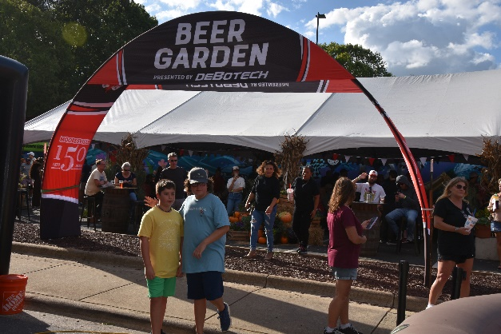
aspects of their permit and they should ensure that patrons are in compliance with relevant policies. Failure to comply can result in the revocation of the permit or the issuance of citations to the Host Organization and/or patrons. The ABC Commission’s current deadlines require that a completed application be submitted to the Mooresville Police Department at least 21 days prior to the event for their approval. In addition, along with the MPD-approved application, you will need to submit the following to the ABC Commission: (Note: Required documentation may change)
- Copy of your rental agreement for the venue and/or your Special Event Permit
- Certified copy of your criminal background check from the County you live in (obtained from the Clerk of Court)
- $50.00 application fee (certified check, cashier’s check, or money order)

To view a complete checklist of ABC permit requirements, visit https://www.abc.nc.gov/permits/limited-special-occasion-permit/open. If the Host Organization will be obtaining an ABC Permit, then Liquor Liability Insurance will be required. The Town of Mooresville will provide guidance on insurance limits depending on the details of the event. Attaining an ABC Permit can be a complex process. It is crucial to plan ahead and coordinate with the Town to ensure that this process runs as smoothly as possible.

Alcohol Service Times

If you plan to provide alcohol at your event, service shall not begin prior to the event start time and the final call must be 30 minutes prior to the end of the event. You may not begin dismantling your event during alcohol service times.

Amplified Sound
When planning your event, you should carefully assess the environment in which your event is proposed to take place in order to develop a plan that best limits the impact of sound generated by event
activities to the surrounding neighborhood. The weather, topography, existing structures, waterways, and open fields can all contribute to the way sound travels and its associated decibel level.

Host Organizations should be sensitive to local businesses and residences when using sound equipment. The Town reserves the right to limit sound amplification so that it will not unreasonably disturb non-participating persons surrounding the event. Complaints of loud, disturbing or unnecessary noise can result in the immediate revocation of the permit by the Town.

Sound Checks
You should plan to limit the impact of sound checks and the use of bullhorns and other amplified sound during set-up and tear-down. Soundcheck times should be communicated to the Event Permit Coordinator so it can be included in the Public Notification.

Excessive Sound
In most cases, issuance of a Special Event Permit will serve as your approval to use amplified sound within your event venue if you have included amplified sound in your Special Event application. However, the Town reserves the right to require you to reduce the volume of, or discontinue, any noise
from your event if a police officer or other Town representative determines that noise from your event is loud, unreasonable, and/or offensive to others.

Parking
When planning an event, consider its impact on parking, including accessible spaces, public transportation, and private lots.

No Parking Postings
If the event involves street closures with parking, "No Parking" signs will be posted by the Town of Mooresville at least 48 hours in advance. Towing may be necessary for cars in restricted areas, but only if the restrictions are clearly posted with "No Parking" signs. If a car is parked on public property clearly marked with a "No Parking" sign, the Host Organization can request towing through the Event Permit Coordinator or the Mooresville Police Department at 704-664-3311. If a car is parked on private property in the event's footprint, the Host Organization must contact the property owner. The necessity of the “No Parking” signs is determined during the permitting process.

Assessing Parking Impact
Evaluate how the event will affect public parking, including accessible spaces, public transportation access, private lots, loading zones, street sweeping schedules, and other venue-specific impacts.

Towing Guidelines
Cars can only be towed if "No Parking" signs are clearly posted. If a car is parked on a street to be closed for an event, representatives of the Host Organization can request towing through the Mooresville

Police Department. During the event, contact the lead officer, an on-site event police officer, or the non-emergency Mooresville Police Department line at 704-664-3311. On public property, the officer will verify signs, attempt to contact the car owner, and request a rotation tow if necessary. The Host
Organization must comply with all local, and state laws, ordinances, and regulations with respect to towing of vehicles, including without limitation Chapter 14 of the Town Code of Ordinances.

Fencing & Barriers
Nearly all events will require fencing or barriers. Fencing and barriers are used to create a layout of your event, as well as provide egress, direction, and safety for the attendees. Fencing may be used to define a venue, create beer gardens, and VIP areas, designate production areas, and other uses approved by the Event Permit Coordinator. Various crowd management tools, including cones, bike racks, and stanchions, may be used to manage lines or create safety zones. Barriers may also be used to support street closures, protect areas from public access, and for other venue safety needs. All enclosed areas require submission of details with the site plan including measurements that will be reviewed for exiting, egress, and capacity.

Fireworks/Pyrotechnics
All activities associated with the use of pyrotechnics, such as fireworks and other controlled explosions, must be reviewed and approved by Mooresville Fire-Rescue and in compliance with the North Carolina
Fire Code. Pyrotechnics and fireworks are only authorized for display by licensed professionals. Persons conducting pyrotechnics or flame effects must be of sound body and mind, be at least 21 years of age, and shall demonstrate knowledge of all safety precautions.

Flame effects such as, hand-held burning torches, flaming batons or hoops, flame acts, fire walking, and flaming sword dancers may require an inspection and/or demonstration to the Fire Marshal prior to
your event date. During your permit process, please be as descriptive as possible. Additional safety requirements and procedures will be influenced by the size of the demonstration and event.
All professionals using fireworks, pyrotechnics, or other flame effects must comply with all federal, state, and local laws and regulations pertaining to such uses. The Host Organization shall hold harmless and indemnify the Town, and its officers and employees from any claim, expense, liability, loss, or damages, including reasonable attorneys’ fees, by whomsoever brought or alleged, resulting from the use of fireworks, pyrotechnics, and other flame effects at the Host Organization’s Special Event.

Animals
If you propose to have activities that involve animals such as pet adoptions, petting zoos, pet parades, or other types of animal exhibits, additional approvals may be required.

Animal Safety
All animals are to be treated in a humane manner and provided with proper care and attention at all times. Animal Control Officers must, at all reasonable times, be permitted full access to examine any/all
animals to be used in and/or kept on the premises of your proposed event. Host Organizations must adhere to established animal welfare guidelines to ensure the proper care, handling, and treatment of animals involved in the Special Event.

Sanitary Standards
Host Organizations hosting events with activities must designate an operator to provide supervision of the animals at all times while animals are at the event venue. Operators are required to maintain
sanitary conditions at all times within the Special Event animal attraction. This includes but is not limited to:
- Regular cleaning and disinfection of animal enclosures, pens, and exhibit areas
- Proper disposal of animal waste and provision of adequate waste management facilities
- The safe and sanitary conditions of petting zoos and animal attractions may be regulated by the North Carolina Department of Agriculture and Consumer Services
- To determine if your event requires a NCDOA permit visit https://www.ncagr.gov/emergency-programs/epanimalcontactexhibit-flowchart2pdf/download?attachment
- The NCDOA Application can be found here https://www.ncagr.gov/emergency-programs/ep-animal-exhibition-permit-application-fillable/open
- The Host Organization must provide handwashing stations for attendees and staff

Public Safety Measures
Operators must implement measures to ensure the safety of attendees, including but not limited to:
- Proper barriers and enclosures to prevent direct contact between animals and visitors, where necessary (This includes the use of leashes and other restraints)
- Supervision by trained staff to oversee interactions between animals and the public
- Emergency procedures in place for handling any incidents involving animals or attendees

Drones
The operation of unmanned aircraft systems (UAS), commonly known as drones, is regulated by the North Carolina Department of Transportation (NCDOT) and the Federal Aviation Administration (FAA). If your proposed event will involve UAS operations, the applicant must comply with all FAA and NCDOT rules and regulations. For the latest information, visit NCDOT’s website at https://www.ncdot.gov/divisions/aviation/uas/Pages/laws-regulations.aspx to view NCDOT’s Unmanned Aircraft Laws & Regulations, and the FAA’s UAS site at https //www.faa.gov/uas/.

Drone Registration Details
You must provide your drone registration, NCDOT pilot certification, flight plan, clear air map, FAA Part 107 UAS pilot’s license, and any other required information prior to issuance of a Special Event Permit. While the Town does not control the use of airspace managed by the FAA, the information is used by public safety officials in coordination with the FAA.

Filming/Photography
To ensure smooth and respectful operations, all filming and photography at events on Town property must comply with the following guidelines:
- Host Organizations are permitted to use professional filming or photography intended for promotional or public use at their event including, but not limited to, promotional content, advertising, media coverage, and social media content produced by professional teams

- Certain areas may be restricted for filming or photography due to safety, security, or privacy concerns; the Host Organization will be informed of any such restrictions during the planning process
- Filming and photography in public areas should respect the privacy of residents, businesses, and attendees; crowd shots or incidental coverage in these areas do not require individual consent but should be conducted responsibly and considerately
- It is the responsibility of the event organizer to obtain any necessary releases or permissions from individuals featured prominently in filmed or photographed content
- If the event is hosted or co-sponsored by the Town of Mooresville, the Town reserves the right to request access to footage or photographs for promotional use
- Filming and photography should not impede the flow of attendees, disrupt event activities, or invade the personal space of individuals who prefer not to be photographed or recorded
- All filming and photography activities must comply with local ordinances, noise regulations, and any additional guidelines provided by the Town of Mooresville

For additional questions or clarification on the filming/photography requirements, please contact the Event Permit Coordinator.

For information on professional/commercial filming not related to a Special Event, please refer to the Film Permit Planning Guide.

Inflatables, Amusement Rides, and Attractions
The Town of Mooresville strives to ensure public safety, the protection of property, and the promotion of responsible operation practices for inflatable devices, amusement rides, and carnival attractions.

Inflatable Operator Responsibilities
Operators must comply with the following guidelines:
- All loose or sharp objects should be cleared before patrons enter the inflatable
- Be aware of the device’s weight limitations and regulate access to the device accordingly
- Maintain a visible presence near the entrance of the inflatable during operation
- Enforce posted safety rules and assist all riders during entry and exit from the inflatable as necessary
- If the inflatable or connected devices exceeds 400 sq. ft., approval is required from Mooresville Fire-Rescue

Inflatable Set-up Procedures
The inflatable location must be free of debris, sharp objects, obstacles and overhead obstructions. Inflatables must be anchored securely as specified in the manufacturer's manual. Ensure all blowers are securely attached and properly connected to power sources before inflating the device. All devices should be in good condition and guarantee safety for all users.

Amusement Rides and Attractions
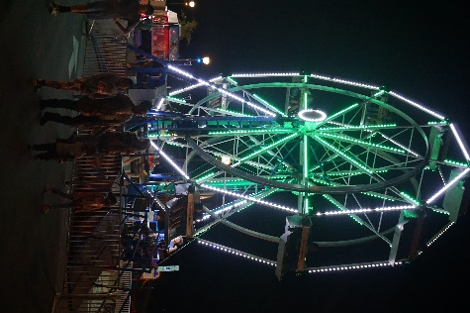
For any attraction that meets the North Carolina Department of Labor (NCDOL) definition of “amusement device,” the vendor must maintain an up-to-date inspection. Rides must be inspected on the day of the event by the North Carolina Department of Labor. Attractions should have the earned certificate of compliance visible or presentable upon any further inspection of the equipment. Operators must adhere to the safety standards and guidelines outlined by the State of North Carolina. It is the responsibility of the Host Organization to ensure the amusement ride/attraction vendor meets all NCDOL requirements, including NCDOL day-of event inspection.

Operator Responsibilities
Operators are responsible for the safe operation and maintenance of amusement rides and carnival attractions throughout the duration of the Special Event. Operators must ensure that all staff members are trained in ride operation, safety procedures, and emergency response protocols. Operators shall prominently display safety signage and instructions for patrons at each attraction. Operators are responsible for scheduling the day-of amusement ride inspection by the North Carolina Department of
Labor. Town of Mooresville staff may check for this prior to the event. If the amusement ride has not been properly inspected by NCDOL, the attraction cannot be used.

Emergency Procedures
In the event of inclement weather, power loss, or any emergency, follow the established emergency procedures provided by the vendor for shutting down the inflatable, amusement ride, or attraction and contact appropriate authorities if necessary.

Inclement Weather
When organizing special events, especially in outdoor settings, ensuring the safety of attendees, staff, and equipment is crucial. The following guidelines help ensure that tents, inflatables, stage covers, temporary structures (such as trusses), and sound or lighting towers are safe and stable.

Tents and canopies must be anchored securely with appropriate weights (at least 40 lbs., but preferably 45-60 lbs.), such as water barrels or sandbags, or drilled anchor stakes when allowed. Follow manufacturer guidelines for anchoring based on the size of the tent and anticipated wind conditions.

Inflatables must be firmly anchored at all points, as recommended by the manufacturer using both ground stakes and weighted bags. Double-check that anchoring points are secure before the event begins.

Inflatables should be set up in areas that are away from other structures, such as fences or trees, to minimize risk if the inflatable is lifted by the wind.

Monitoring and Forecasting
Utilize reliable weather forecasting services to monitor weather conditions leading up to and during the event. The Town of Mooresville reserves the right to revoke the Special Event Permit if the weather will create unsafe conditions for the event including, but not limited to lighting.

Wind Monitoring:
Wind speeds of 20 mph: Review the security of tents, inflatables, and temporary structures.
Wind speeds of 25 mph: Consider removing inflatables and lightweight structures.
Wind speeds of 30 mph: Begin implementing pre-planned mitigation or evacuation strategies, particularly for larger structures such as stages or lighting towers.

Wind speeds exceeding 35 mph: Close the event and evacuate attendees if structures are deemed unsafe.

Site Plan/Route Map
As a Host Organization, you are responsible for providing a clear and fully detailed site plan or route map that illustrates all aspects of your event plans, including street closures, event boundaries/routes, event infrastructure and event operational elements. The base map used for the site plan or route map must be depicted in a manner that the Town and other public agency authorities can clearly see the scaled dimensions, street names, and locations of all event components proposed on the site plan or route map.

Boundaries and Routes
- Your site plan or route map must include the names of all streets and/or areas that are part of the proposed event, including auxiliary parking and production areas
- If your event includes activities with moving routes of any kind such as a parade, run, or cycling event, the direction of travel and all proposed lane closures must be depicted on the site plan or route map
- The location of fencing, barriers and/or barricades must be depicted on your site plan or route map. This includes barriers used to denote stationary elements such as beer gardens and to articulate participant flow for Moving Events
- Your site plan or route map must identify a minimum of twenty ft. (20’) emergency access lanes that must be kept clear throughout the event venue
- All access routes, removable fencing, and exit locations should be clearly identified on your site plan or route map

Event Infrastructure and Operations
Your site plan or route map should include the location of all event infrastructure and operational elements identified in your permit application including, but not limited to:
- Fencing
- Beer Gardens and production areas (include a close-up of the beer garden configuration(s) with all exit locations, serving fixtures, furniture and tenting)
- Portable restrooms and sinks

- Trash and recycling containers and dumpsters
- Storm drains and run-off containment
- Water stations, water, and ice supplies
- Generators and other sources of electricity
- Fuel storage facilities
- Placement of any vehicles and/or trailers including production and shuttle areas
- Portable, prefabricated, or site-built structures, bridges, staging, platforms, bleachers, or grandstands
- Other related infrastructure components not listed above but included in your permit application
- Stages and entertainment areas
- Inflatables, mechanical rides, climbing walls, obstacle courses, games, petting zoo/animal rides, children/teen areas, sport demonstrations and other activities
- Tents, canopies and/or booths. Booth location of all vendors cooking with flammable gases, open flames, or barbecue grills must be identified. A close-up of the food and/or cooking area configuration with all fire extinguisher locations is required
- Tables, seating, and other furniture
- Parking, accessible parking, drop-off, limo/taxi zone, shuttle locations, etc.
- Other related infrastructure or operational components not listed above but included in your permit application

Security/Safety Plan
Safety is the Town of Mooresville’s number one priority at all events and should always be considered the top priority when you are planning an event. You may be required to employ off-duty police officers at your event to ensure the safety of all attendees. Police officers are the most common and preferred method of security at Special Events in the Town. During the event permitting process, the Mooresville Police Department will review each application and provide recommendations on the number of officers or other security needed for your event. Personnel will be assigned to your event and all applicable fees will apply. Bag checks at events cannot be conducted by the police department. Additionally, some events may be required to submit an Emergency Action Plan (EAP) during the application process. This plan should include emergency access for EMS, crowd managers, communication methods for workers
and attendees, and paths of egress to evacuate the venue. Town personnel will review each plan and make recommendations.

Medical
To ensure health and safety, all Special Events must be equipped to assist with medical emergencies. The requirements for medical equipment may vary based on the number of attendees at your event.

Requirements for all Events
Each event must designate an event representative who will be onsite at all times while the permit is in effect to call 9-1-1 if necessary. This individual is required to attend the event for the duration of the permit. It is the Host Organization's responsibility to provide any medical and safety kits that are

necessary. The Town of Mooresville holds no liability for any injuries that occur during the duration of events.

Requirements for Events with 2,500 Attendees or More
In addition to a designated 9-1-1 caller, Mooresville Fire-Rescue will determine the necessary amount of on-site emergency personnel required for the event. This comprehensive approach helps to ensure the well-being and security of all attendees.

Larger events may require a specific medical plan as deemed by Town staff upon review of your permit application. Events with a higher potential for risk are required to implement an appropriate medical plan to address the specific needs of the attendees and/or participants.

Transportation
Your event plans must include planning for the safe arrival and departure of event attendees, participants, performers, volunteers, and vendors in a manner that is suitable for the venue in which your proposed event will take place.

Planning Guidelines
Please review the following checklist:
- Traffic Control Personnel: Ensure all traffic control in the public right-of-way is conducted by a representative of the Mooresville Police Department or an authorized civilian who has been duly appointed by the Mooresville Chief of Police pursuant to G.S. 20-114.1.
- Street Closure: Include all proposed street closures in your permit application and obtain authorization from the Town of Mooresville.
- Shuttle Approval: Obtain approval from the property owner for the use of property for shuttle services. If authorized by a property manager, ensure the manager is authorized to approve its use on behalf of the owner.
- Shuttle Stops and Routes: The Town will evaluate shuttle stops and proposed transportation routes as part of the permit process.
- Taxi/Limo Zones: Coordinate any taxi/limo drop-off/pick-up zones with the Town of Mooresville.
- Accessible Parking/Access: Include accessible parking and/or access in your event plans. Replace any displaced accessible parking with an equal or greater number of accessible spaces and provide directional signage as needed.
- Traffic/Safety Equipment: If your event involves street closures, obtain traffic/safety equipment for safe closure of the venue and ensure proper detour and parking information is posted.
- Traffic Control Plans: If the event will alter or impact the flow of traffic (vehicle, bicycle, and/or pedestrian) on public streets, traffic control plans may be required. Traffic control should be coordinated with the Mooresville Police Department.

The Mooresville Police Department will determine if your event requires traffic control to facilitate vehicular, bicycle, and pedestrian movement on Town streets and public rights-of-way affected by your event.

Accessibility
Your event plans must comply with all Town, county, state, and federal disability access laws and regulations applicable to your proposed event activities. All temporary venues, related structures, and
outdoor sites associated with your event must be accessible to all disabled persons. This should include, but is not limited to:
- Accessible Path of Travel Throughout Venue
- Accessible Parking/Transportation
- Accessible Restrooms/Sinks
- Accessible Booths/Service Counters
- Accessible Staging/Seating

You are not limited to the examples listed above but must establish procedures that produce equivalent or better results and ensure that you meet all local, state and federal laws.

Waste Management
The Host Organization should strive to maintain a sanitary and waste free environment. You are responsible for providing proper disposal of trash and recyclables generated by your event and its attendees, including during the set-up, event duration and breakdown timeframes associated with your event. Some parks have trash and recycling receptacles provided; however, additional trash mitigation
strategies may be required based on the size of your event. The number of attendees you expect at your event will determine the waste management strategy needed.

Sanitation Services
All events are required to have waste receptacles. The information below provides guidance for determining if your event will require the Town of Mooresville’s waste receptacles or if you are permitted to provide your own. Various protocols must be followed based on the estimated attendance of your event. Larger events may require additional Town of Mooresville Sanitation staff members to help with waste mitigation during the event.

0-500 Attendees
Host Organization may organize their own waste cleanup methods. Host Organization must provide their own trash receptacles and trash bags to dispose of trash. Host Organization must remove all trash from the venue and strive to maintain a trash-free environment before, during, and after the event.

Special Event does not require additional staff for waste collection at this level of event attendance.

500-5,000 Attendees
Host Organizations are required to use the Town of Mooresville’s Special Event Waste Receptacles. The number of waste receptacles will be determined by the Town of Mooresville Sanitation Department.

Waste Receptacles will be delivered to the venue one day prior to event date and stationed in a central location.

It is the responsibility of the Host Organization to distribute the receptacles around the perimeter of the event as identified in the Site Plan. The Host Organization is required to return Special Event Waste Receptacles to the original drop location at the conclusion of the event.

Sanitation Staff will remove waste from receptacles after the conclusion of the event.

Special Event does not require additional staff for waste collection at this level of event attendance.

5,000+ Attendees
Host Organization is required to use the Town of Mooresville’s Special Event Waste Receptacles. The number of waste receptacles will be determined by the Town of Mooresville Sanitation Department.

Waste Receptacles will be delivered to the venue one day prior to event date and stationed in a central location. It is the responsibility of the Host Organization to distribute the receptacles around the perimeter of the event as identified in the Site Plan. The Host Organization is required to return Special Event Waste Receptacles to the original drop location at the conclusion of the event. Sanitation Staff will remove waste from receptacles after the conclusion of the event.

Special Event at this level of event attendance requires Town of Mooresville Sanitation Staff for waste collection during the event. The Town of Mooresville Sanitation Department will determine how many
staff will be required based on the scope of the event and estimated attendance. Sanitation Staff will be billed to the Host Organization at a rate of $30 per hour per staff member. Sanitation Staff will arrive 30 minutes prior to event start time and remain 30 minutes after event end time for waste management.

Street Sweeper Services
All Special Events with an expected attendance of 5,000 or more that include a street closure will be required to utilize the Town of Mooresville’s Street Sweeper services at the conclusion of the event. The number of staff and hours needed will be determined by the Town of Mooresville Stormwater Division. Host Organizations will be billed at a rate of $30 per hour per staff member.

Conclusion of Event
At the conclusion of your event, the event venue and surrounding areas must be cleaned and returned to a condition equal to, or better, than the condition prior to the onset of your event activities. Failure to
perform adequate clean-up and/or repair any damages may result in additional cleaning fees and/or denial of future Special Event permits.

Restrooms/Sinks

Restroom Facilities
Restrooms and sinks are an important component of event infrastructure. You must provide portable restroom facilities at your event unless you can substantiate the sufficient availability of both accessible and non-accessible facilities in the immediate area of the event site that will be available to the public
during your event. Event organizers are required to provide restroom facilities for participants and attendees, with at least 5% (and at least one) being ADA compliant. The minimum requirement is one

toilet per every 250 attendees. Event organizers can meet this minimum either by renting portable toilets or by attaining written permission to use the facilities of adjacent businesses.

Sinks and Hand-Sanitizing Facilities
The provision of hand-sanitizing facilities or sinks is required in all restroom areas and is separate and in addition to any hand-washing facilities required for food preparation and sales.

MOVING EVENTS (PARADES, RACES AND WALKS)

Moving Events (Parades, Races, and Walks) are organized activities that follow a designated course and may involve full or partial closure of Town streets, sidewalks, or greenways. Sometimes Moving Events require a rolling road closure that can be facilitated by the Mooresville Police Department.

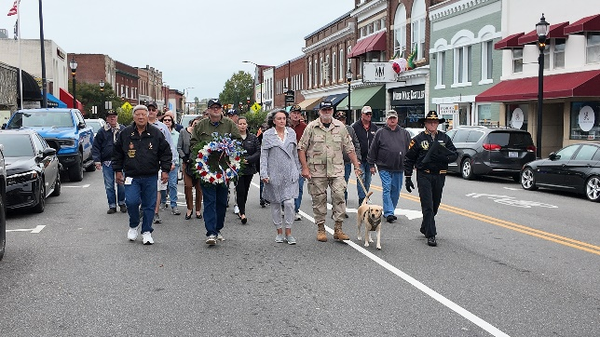
Moving Event Route Planning
Moving Events, such as Races, Walks and Parades, may require a rolling closure where non-participants will be temporarily stopped to allow for event participants to safely move unobstructed along the course. You will be required to provide a detailed route plan with a turn-by-turn description and course map of the intended route. Sites may be denied if the area of impact is too great or causes too many
complications to residents and businesses. All events must have a start and end location and a start time and end time. The total distance of the event must be provided in miles.

Race/Walk/Parade Route & Site Plan
Applicants must provide a plan/map showing:
- Racecourse or Parade Route
- Start/Finish points
- Event information, food and merchandise tents
- Stage and sound equipment
- Banner placement
- Participant staging and dispersal sites
- First Aid Stations

Moving Event Guidelines:
- If your event uses temporary staging, seating, or bleachers of any type, you will be required to provide this information in the temporary structures section
- If utilizing animals in the parade (including horses) you must have a team member designated to follow the animal during the parade route (and holding areas) to clean up any waste
- Race/Walk organizers will be required to clean up all water cups, sports gels and all other waste left on the Race or Walk course, in Town parks, on sidewalks, and all other public right-of-ways;

- water stations must not block public access to residential and commercial properties, sidewalks, and other public right-of-ways

If parade floats are being used, they must adhere to the following guidelines:
- Floats must maintain a maximum height of 13 ft., maximum length of 55 ft., and maximum width of 12 ft.; these parameters are for the entire entry including float, tow vehicle and hitch
- Participants riding on floats may not get off or on once the entry begins moving
- Parade Marshals/Ambassadors are required to walk on each side of the float during the parade route to ensure the safety of all participants
- Throwing or distribution of items of any kind from a float or parade unit is strictly forbidden

PUBLIC NOTIFICATION

To improve communication and keep citizens, businesses, and other establishments fully informed of all events that will potentially impact their area, Host Organizations must collaborate with the Town of Mooresville to follow the Public Notification procedures set forth in this guide. Failure to comply with these procedures may result in a reduced event evaluation score and may affect a Host Organization’s ability to host future events.

Do not announce, advertise, or promote your event until you have completed Phase I of the Special Event Application Process and have received approval from the Town of Mooresville to proceed to Phase II. The Town of Mooresville will assess the feasibility of your event, check availability, and make an approval determination for the event during Phase I of the Special Event Application process. The Town
assumes no liability if the event is not approved. Selling tickets, advertising, gaining sponsorship, and other activities done prior to full approval of event is done at the risk of the Host Organization.

Public Notification Requirements
In order to effectively communicate information regarding Special Events to the community, the Host Organization must provide the information below to the Town of Mooresville during the permit application process and notify the Town of any establishment whose entrance and/or parking lot may be
blocked due to the event. This includes all affected residents, businesses, schools, and places of worship.
- Name of Event
- Date and timeframe of event, including dates and times of set-up and tear-down
- Event location
- Description of event and information about the noise impacts of event, such as music or fireworks, and their timeframe
- Description of road closures, including locations and times
- Name, email address, and phone number of contact for Host Organization
- Name, email address, and phone number of Town of Mooresville Event Permit Coordinator

- Website associated with event (if applicable)

The Town of Mooresville will notify affected businesses and residents at least 30 days prior to the event date.

INSURANCE

Insurance Requirements

All Special Events hosted on Town property require General Liability Insurance. In some cases, additional insurance coverage will be required based on the event activities.

Certificate of Insurance and Additional Insured Endorsement
The Host Organization shall purchase and maintain required insurance, providing coverage for the Special Event with an insurance company authorized to conduct business in the State of North Carolina.

The Host Organization is responsible for providing a Certificate of Insurance (COI) with an Additional Insured Endorsement reflecting General Liability insurance of at least $1 million per occurrence and $2 million aggregate. The “description section” on the certificate of insurance MUST note that Special Events are covered under the general liability policy. Without this in the description section of the COI, you will be required to provide additional verification of Event Liability insurance in the COI with a minimum of $1 million per occurrence and $2 million aggregate. State minimum Workers’ Compensation coverage must be verified on the COI when not exempted by North Carolina General

Statutes. If exempt, you must still sign a workers’ compensation waiver form, which can be found in the Glossary section of this planning guide.
*PLEASE NOTE: The Certificate of insurance “description section” should be specifically worded: “The Town and its officers, employees, and volunteers are included as Additional Insured.”
The Town of Mooresville Address must also be listed as the Certificate Holder on the COI as follows:
Town of Mooresville
413 N. Main Street
Mooresville, NC 28115

Additionally, depending on the event details, you may also need to confirm Commercial Auto and/or Liquor Liability coverage on the COI.

The insurance and endorsements shall provide coverage for the entire duration of dates and times for which the Special Event Permit is in effect, including set-up and dismantle dates. If the event includes the use of alcohol, whether or not it is distributed on Town property, Liquor Liability Insurance may also be required.

You can find a sample Certificate of Insurance and Additional Insured Endorsement in the Glossary section of this planning guide.

Liability and Indemnification
Host Organization agrees to hold harmless, indemnify, and defend the Town of Mooresville, its directors, officers, employees, and affiliates (collectively, “Indemnified Parties”) from and against all claims, demands, actions, suits, damages, liabilities, losses, settlements, judgments, costs, and expenses, including but not limited to reasonable attorney's fees and costs, (collectively "Claims") of, brought by, or involving a third party, actually or allegedly, directly or indirectly, arising out of or related to (1) the Special Event or any act or omission of the Host Organization, its directors, officers, employees, affiliates, vendors, contractors, or attendees, in each case whether or not caused in whole or in part by the
negligence of the Host Organization, or any other Indemnified Party, and whether or not the relevant Claim has merit.

EVENT EVALUATION

Site Visit
Town of Mooresville staff may perform routine site visits for Special Events. Town staff will ensure compliance with all regulations outlined in the Special Event Permit, this Event Planning Guide, the Town Code of Ordinances, and all other applicable local, state, and federal statutes and regulations.

Event Performance Evaluation
The Event Permit Coordinator will complete an Event Performance Evaluation following each event to measure the success of the Host Organization in conforming to policies and permitted activities. Events
with an unsatisfactory performance rating may have additional requirements imposed for future years or may be denied for all future events. Host Organizations will receive their performance evaluation within 15 days after their event.

Damages and Outstanding Bills
Any clean-up and/or repair costs incurred by the Town, or if necessary, contractor’s fees incurred by the Town, due to the applicant’s failure to clean and restore the site following the event shall be the responsibility of the Host Organization. Additionally, the Host Organization is responsible for cleaning,
clearing, repairing, or paying to repair any damage to surrounding properties resulting from the Host Organization, its employees, vendors, contractors, or event attendees.

Letter of Intent
If a Host Organization receives a satisfactory evaluation following their event, they will be invited to submit a Letter of Intent to reserve the same date and location for the event the following year. Failure to submit a Letter of Intent within 15 days will open that date or location up to other interested parties. Please note that acceptance of a Letter of Intent does not guarantee that a Special Event Permit will be issued for the following year. Annual events will still need to submit a complete application every year and approval of that event will follow the same procedures outlined in this guide.

TOWN-SUPPORTED EVENTS

The Town of Mooresville has established the Town-Supported Event Program with the goal of creating a vibrant, event-friendly community that brings people together while supporting the local economy. Mooresville is proud of its rich traditions and exciting events that enhance the cultural, social, and recreational life of our town. Through this program, we hope to foster collaboration between event organizers, local businesses, and residents to create a welcoming atmosphere for everyone.

The Town of Mooresville has introduced the Town Supported Event Program to better manage and evaluate the wide range of events that take place on town property, particularly those that require street closures.

By qualifying events through this program, we can more effectively allocate town resources, minimize disruptions to traffic and residents, and maintain a balance between celebrating important occasions and safeguarding the town’s operational efficiency.

Application/Deadline
Applications are due at least 120 days prior to the event date.

Application can be found in the Resources section of the Event Planning Guide.
Please submit a complete application ensuring all questions are answered in as much detail as possible. The application should be submitted to info@mooresvilleevents.com.

Eligibility
To be eligible, an organization must submit the TSE (Town Supported Event) Application, along with all required documents by the deadline and must meet the following guidelines:
- Applicants must be nonprofits with current IRS status licensed to do business in North Carolina
- Host Organization (or a local chapter thereof) must be located in the Town of Mooresville corporate limits
- The event must be compliant with the Special Events Ordinance and must obtain and maintain all necessary licenses, permits, and insurance as required by Town’s event permit policies
- Events shall be free and open to the public
- The event must encourage community engagement
- Event must maintain a satisfactory post-event performance evaluation

Ineligible Events
- Any event on private property or at a residence
- Trade shows, ceremonies, conventions, conferences, job fairs, workshops, etc.
- Residential block parties
- 5K Runs/Walks
- Special Events where the primary purpose is fundraising

- Special Events intended to convey a religious message or advocate a political position (with the exception of national holidays)
- Events like holiday parties, birthday parties, anniversaries, family reunions
- College, church or school sporting events

Allowable Town Support
- Mooresville Police Department (MPD) Personnel
- MPD Cruisers
- Sanitation Services (to include Town waste receptacles and Town of Mooresville Sanitation personnel)
- Street-Sweeper Services and Personnel
- Street Closure Equipment and Personnel

The support listed above is a complete list of all allowable fees.

Review Criteria
Types of Special Events Considered:
National Holidays/Remembrance Days: Town support will be considered for events that celebrate national holidays (e.g., Independence Day, Memorial Day) and remembrance days (e.g., Veterans Day, Martin Luther King Jr. Day).

Community Events: Events that promote community engagement and local culture (e.g., festivals, street fairs, etc.) are eligible for Town support.

Special Considerations: The Town may consider other events for support on a case-by-case basis, particularly those that have significant cultural, historical, or social importance to the community and generate tourism.

Approval Criteria
The following criteria will be considered during the review process:
- Special Events that have a town-wide or regional economic impact
- Historical significance or relevance of the event (e.g., national holidays, remembrance days, etc.)
- Special Events must be free and open to the public
- Potential to generate tourism and attract visitors. The Town will prioritize events that support local businesses, increase visibility for Mooresville, and bring economic benefits to the community.
- Impact on Public Safety, Resources and Town Operations
- The organization’s capacity to successfully host the event
NOTE: The Special Events Committee is guided by the review criteria. No one attribute is controlling. As the Town has limited public resources available and is the steward of those funds, it is in the Town’s sole discretion to determine which events it can provide support, if its support recurs year to year, and if the level of support increases or decreases. The Town of Mooresville has the right to deny support to an event for any reason in the public interest, including but not limited to decisions based on financial limitations.

Application Support Documents
Include copies of the following required documents:
- IRS letter of non-profit tax-exempt status
- Proof of Address

Application Timeline
- Support determined and awarded by the Town of Mooresville Special Events Committee (Host Organizations must apply at least 120 days prior to the event date)
- All applicants are notified of the results of their support within 30 days of request
- Special Event Permit Request must be submitted at least 90 days prior to the event date

Final Report
A final report is required from each event receiving support at least 30 days post-event and should include attendance figures, the number of vendors, and volunteers.

Town Obligation
The Town of Mooresville is only a supporter of the event, not a promoter or co-producer of the event. The Town will not be liable for any debts incurred for the event or claims that arise out of the event. In making an award, the Town does not assume any liability or responsibility for the ultimate financial success of the event.

Please contact the Town of Mooresville Arts & Events Division with any questions about the Town Supported Event Application at info@mooresvilleevents.com.

RESOURCE GLOSSARY

Additional Insured Endorsement Sample 39
Certificate of Insurance Sample 40
Request for Workers’ Compensation Waiver 41
Planning Maps 42
Application for Special Event Support 47
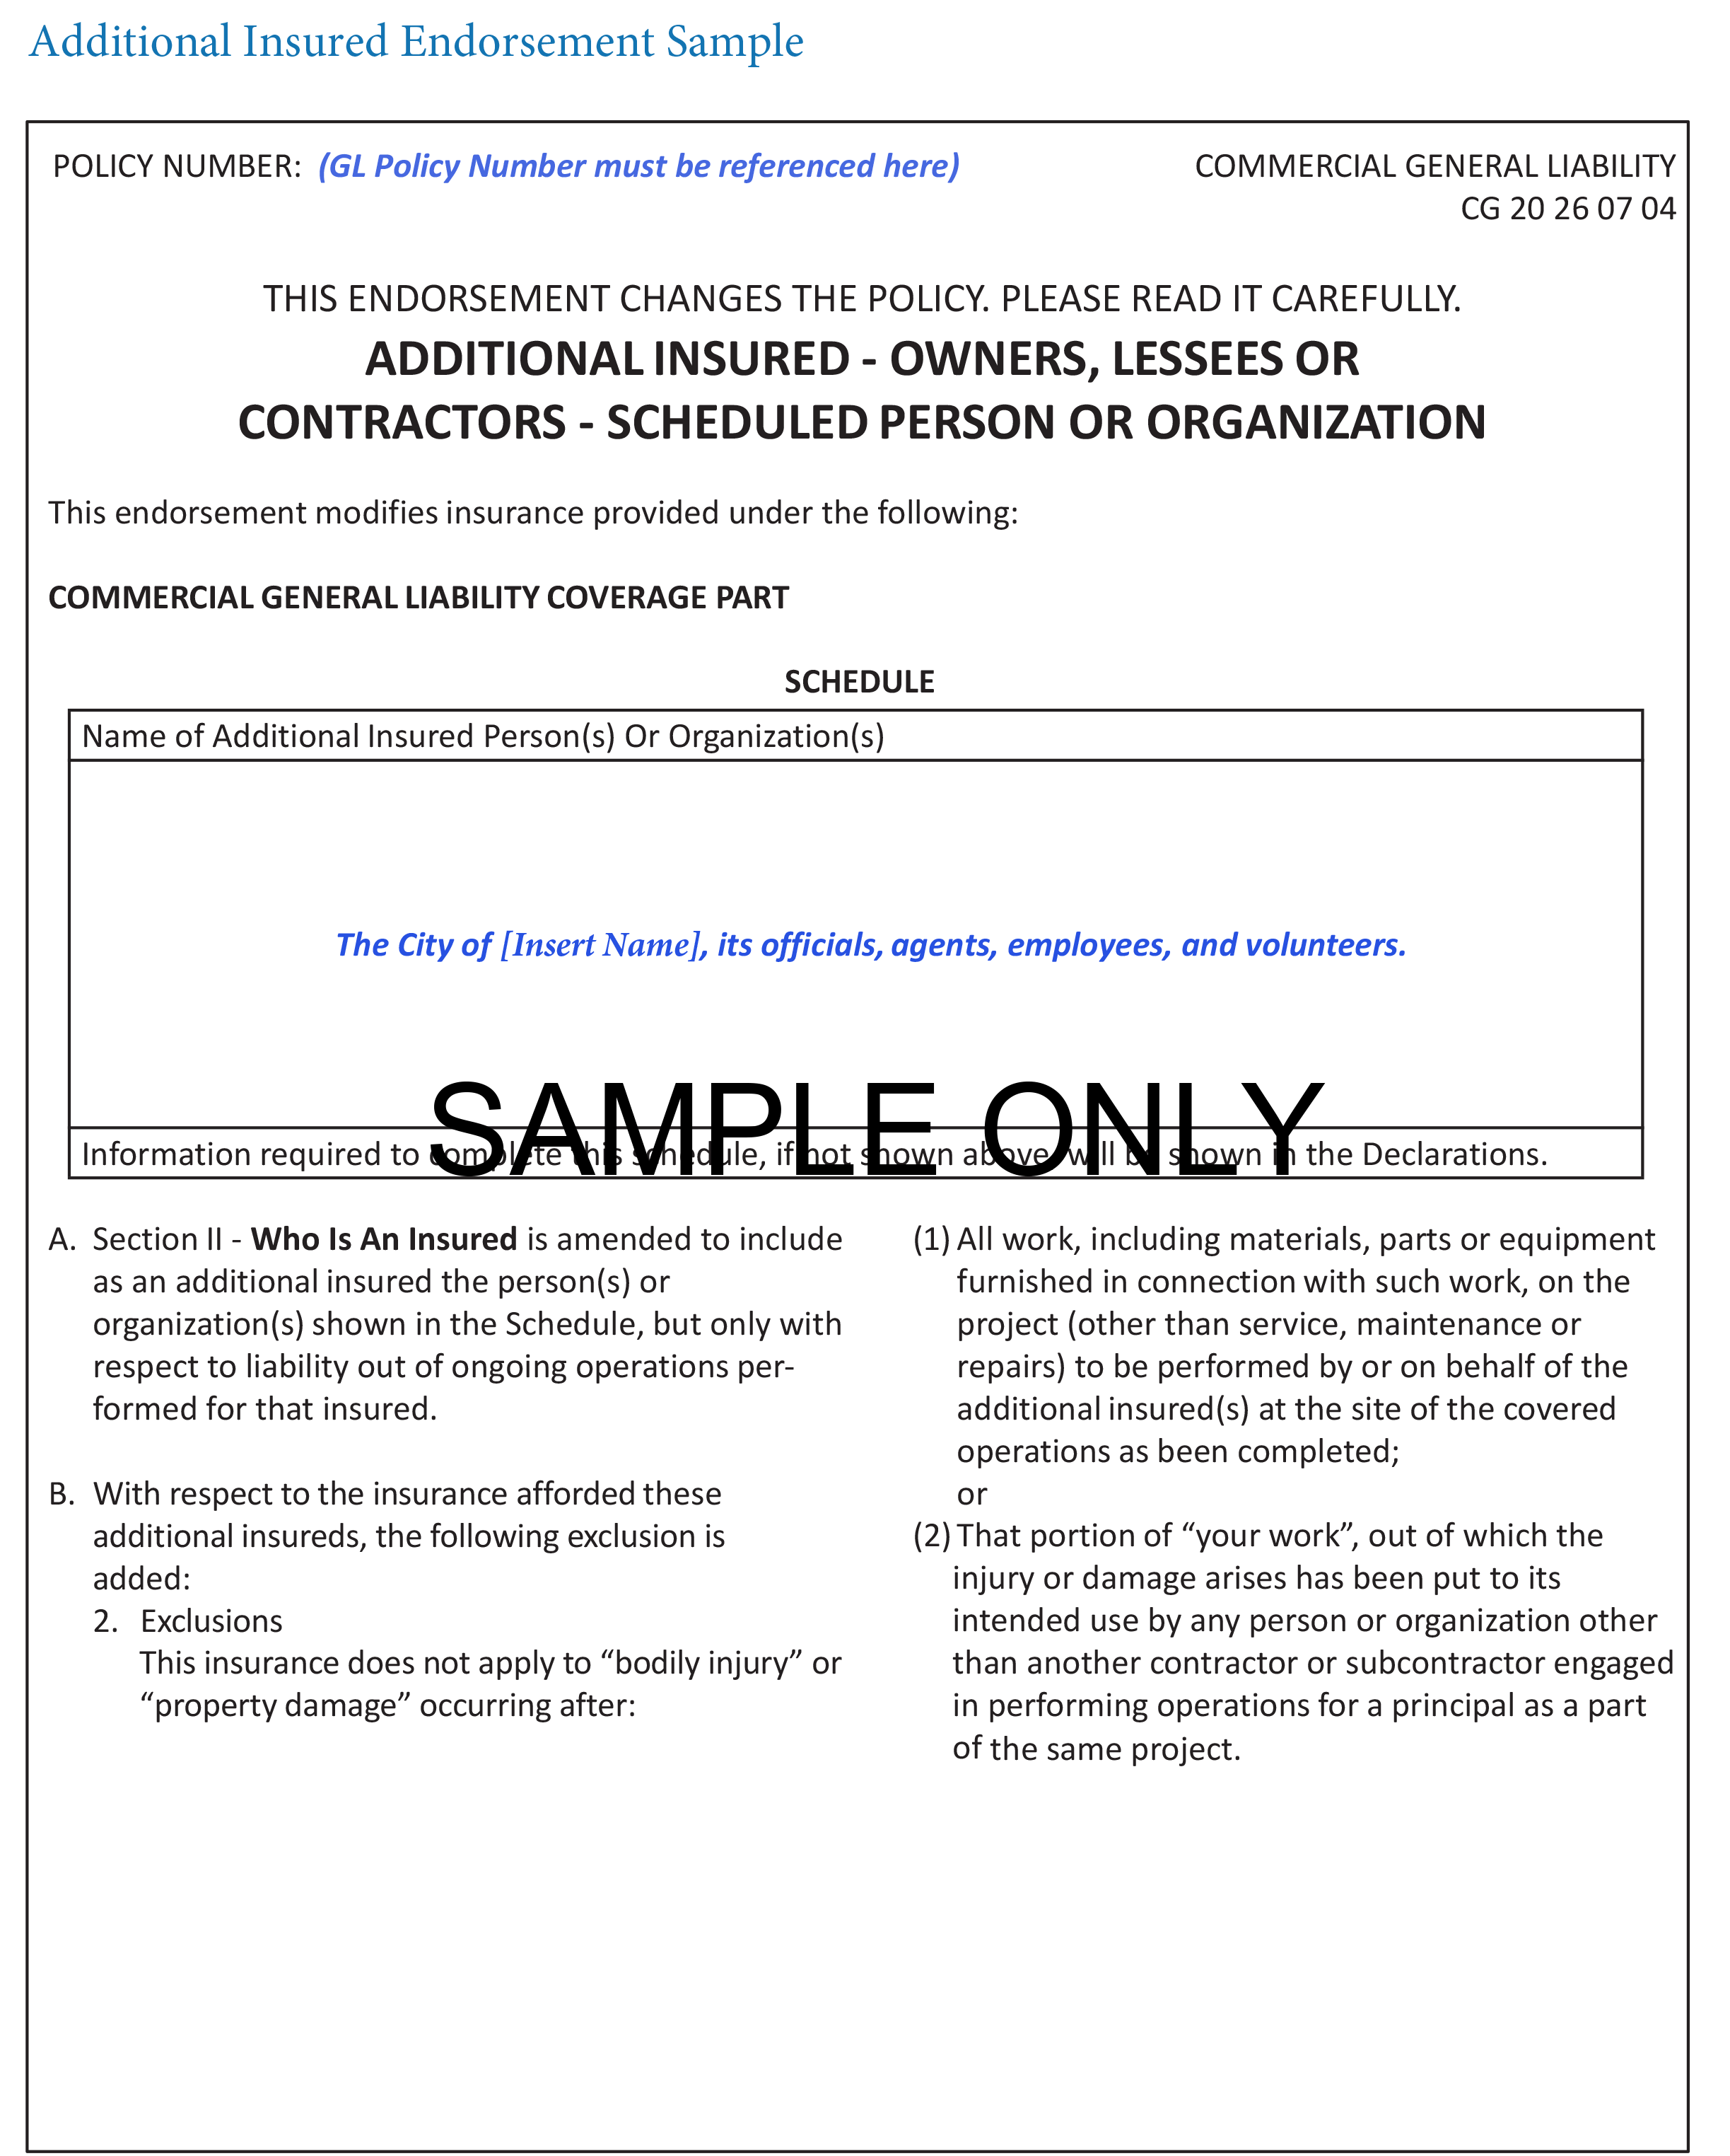

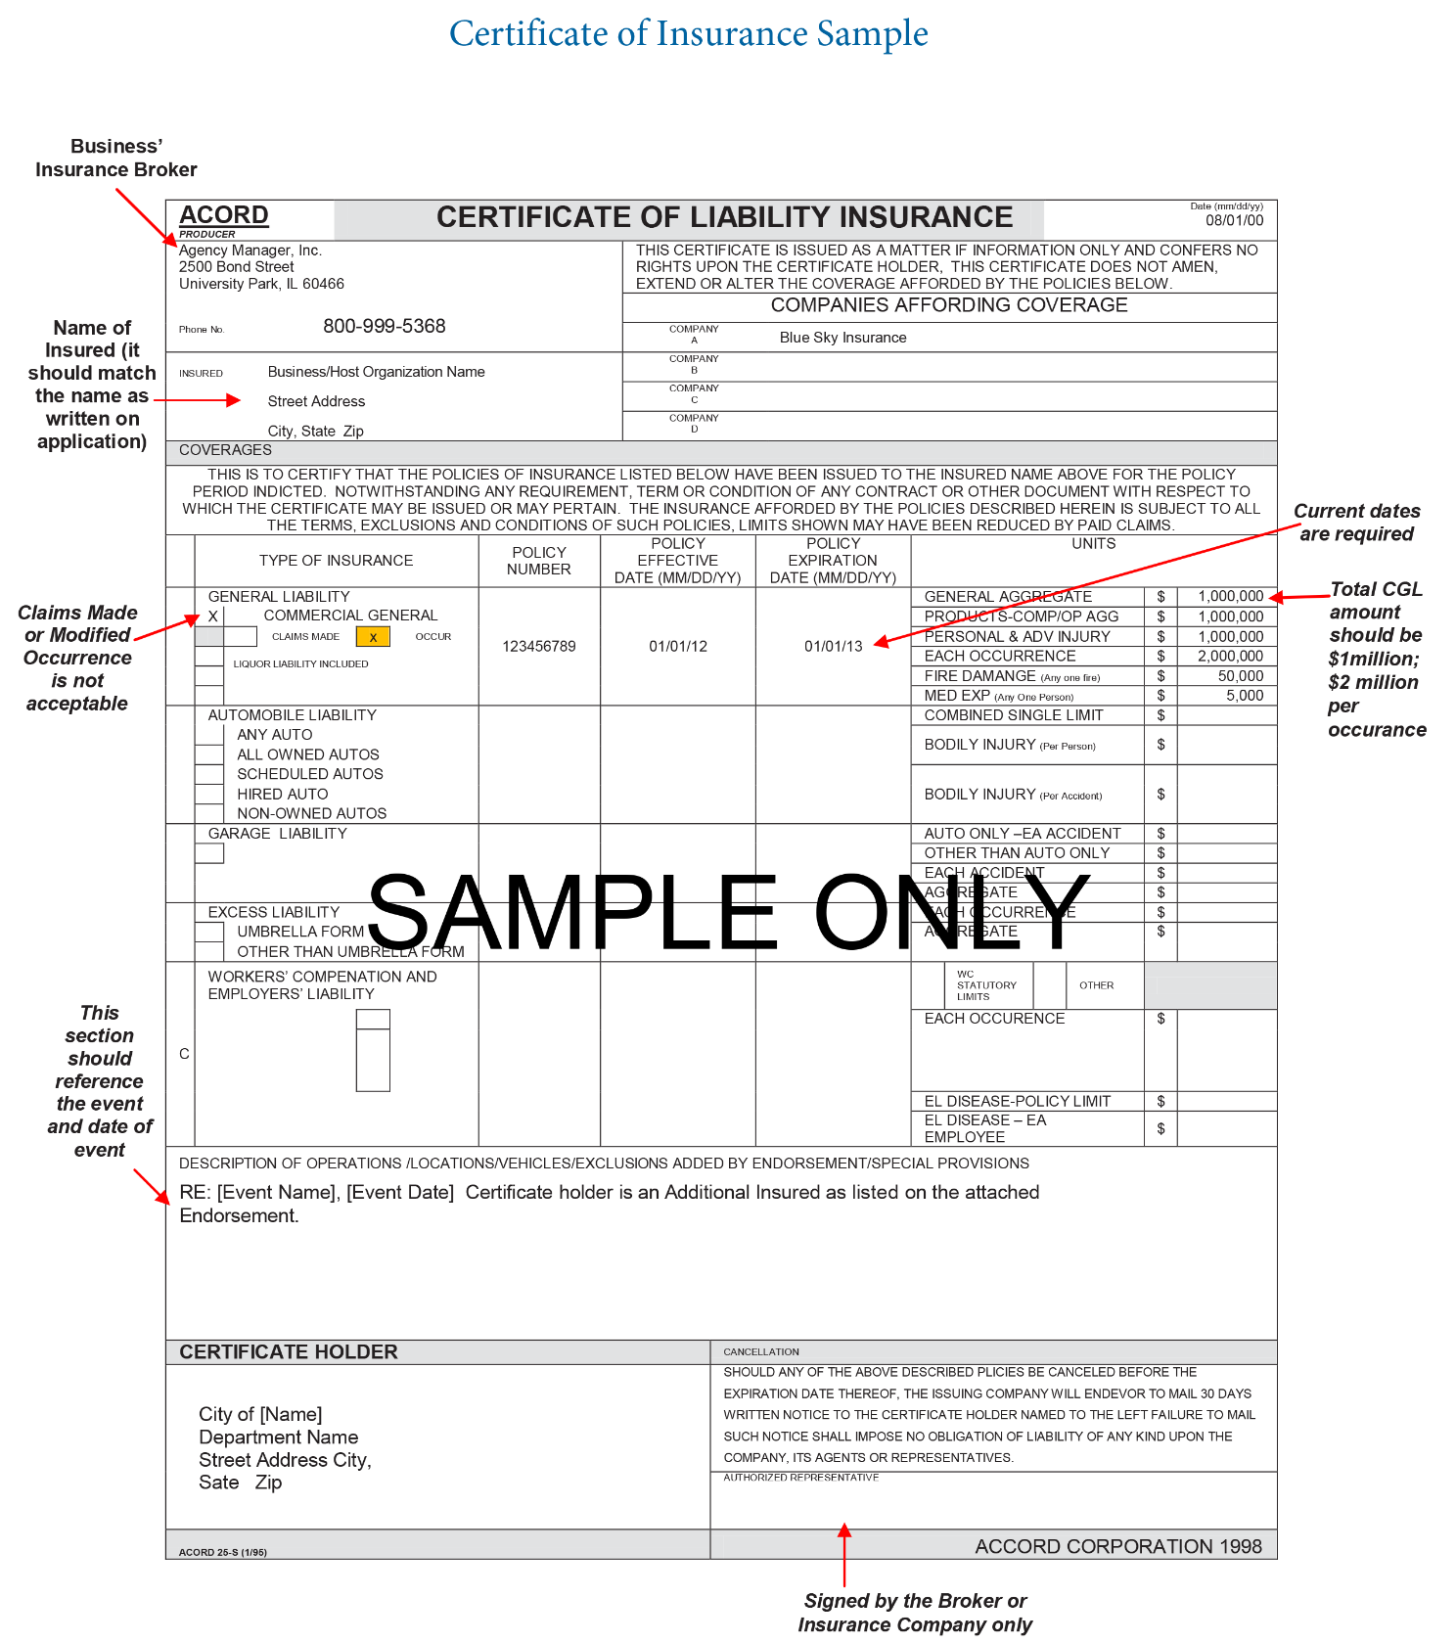

REQUEST FOR WORKERS’ COMPENSATION WAIVER

DATE: ___________________________
JOB/CONTRACTOR REFERENCE NUMBER:
To Whom It May Concern:

I,______________________________, acknowledge that I am an independent contractor of the Town of Mooresville, North Carolina for the above captioned job/contract.
In connection with the contract between us, I hereby request that the Town of Mooresville waive the contractual obligation that I carry the standard Workers’ Compensation and Employers’ Liability insurance for the following reasons:
- I have fewer than three (3) employees and, therefore, am not legally required by the State of North to have such insurance;
- I am not in the construction industry;
- I agree to be responsible for any injuries to myself or persons employed or otherwise engaged by myself for the purpose of completing the obligations contained in the captioned job/contract;
- In consideration for the requested waiver, I agree to indemnify and hold harmless the Town of Mooresville from any and all claims for personal injury, including death, brought against the Town of Mooresville or its officers, employees or agents by myself and/or persons employed or otherwise engaged by myself (contract employees) and related, directly or indirectly, from our provision of services in completing the obligations contained in the captioned job/contract.

____________________________________________________
_{SIGNATURE}

Request of a waiver for workers’ compensation is subject to review by the Town of Mooresville
and does not guarantee acceptance.
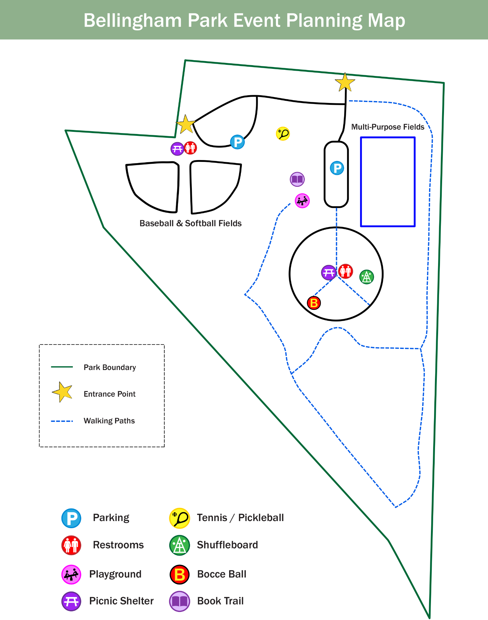
Application for Event Support
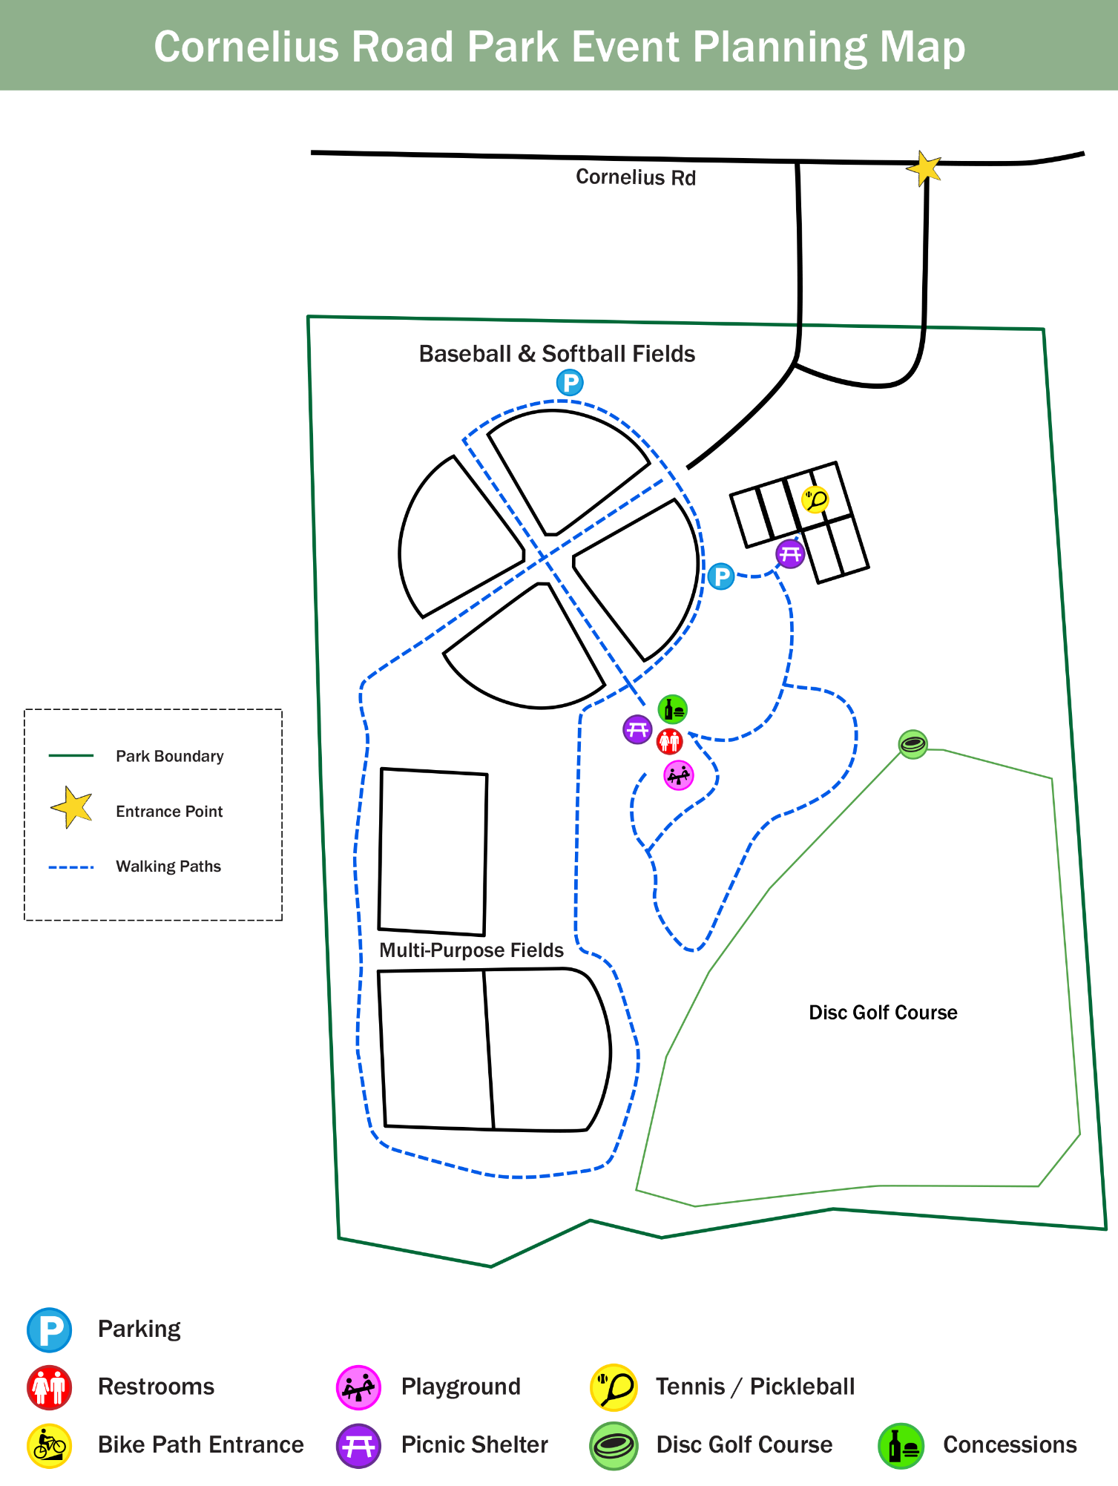
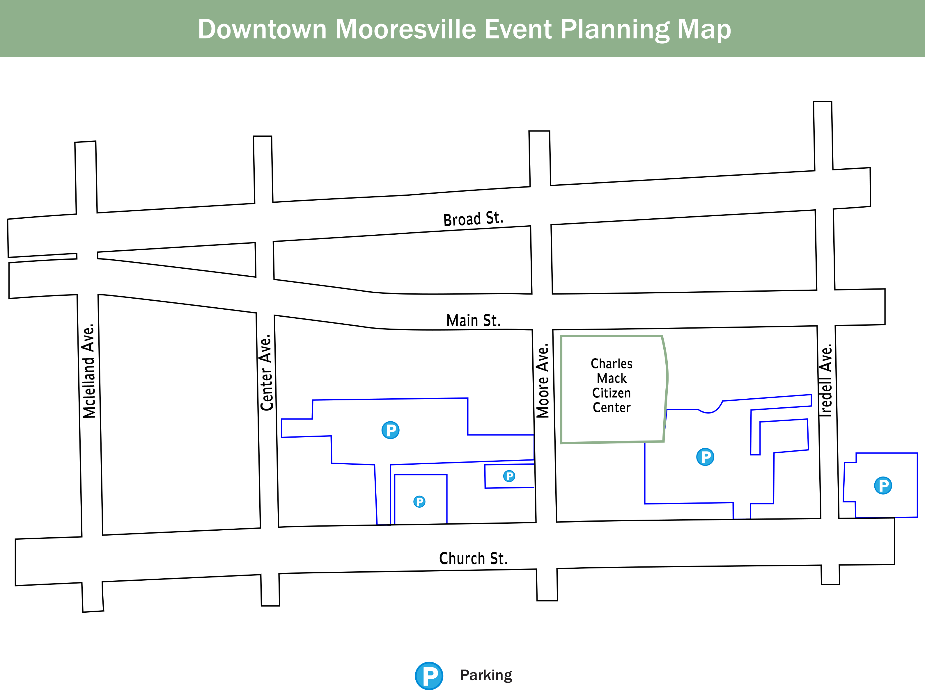
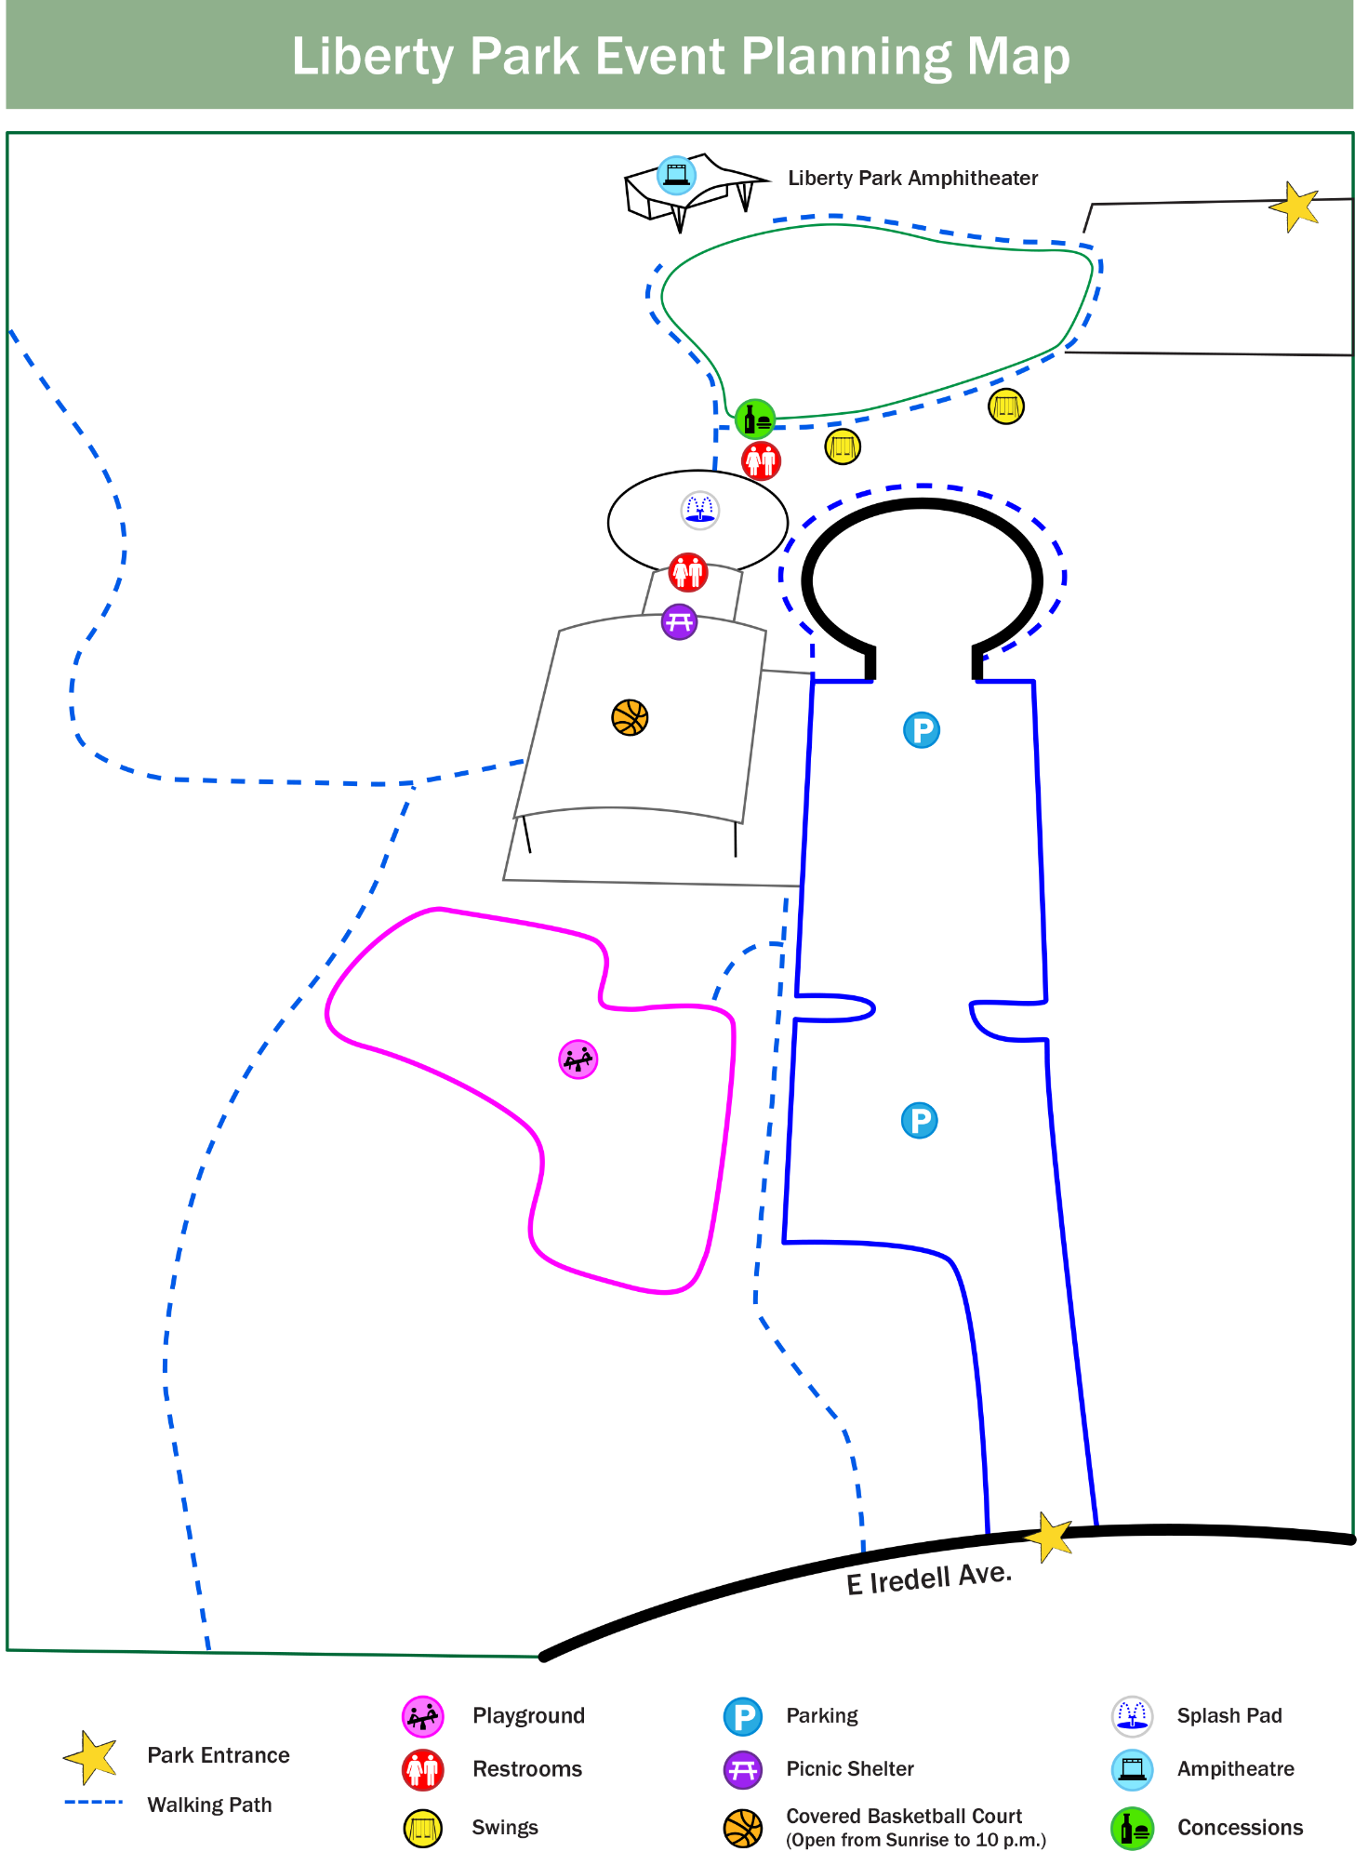
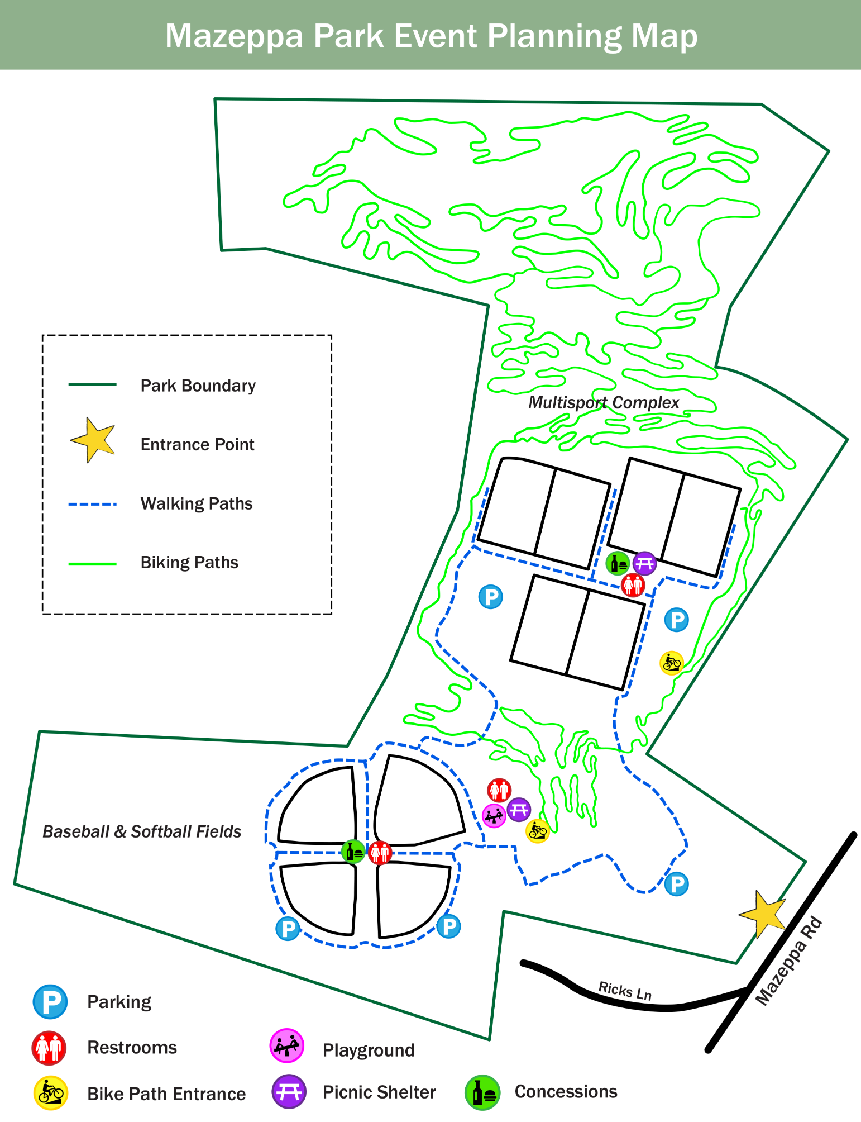

APPLICATION FOR SPECIAL EVENT SUPPORT
The Town of Mooresville has established the Town-Supported Event Program with the goal of creating a vibrant, event-friendly community that brings people together while supporting the local economy. Mooresville is proud of its rich traditions and exciting events that enhance the cultural, social, and recreational life of our town. Through this program, we hope to foster collaboration between event organizers, local businesses, and residents to create a welcoming atmosphere for everyone.
The Town of Mooresville has introduced the Town Supported Event Program to better manage and evaluate the wide range of events that take place on town property, particularly those that require street closures.

By qualifying events through this program, we can more effectively allocate town resources, minimize disruptions to traffic and residents, and maintain a balance between celebrating important occasions and safeguarding the town’s operational efficiency.

Application/Deadline
Applications are due at least 120 days prior to event date.
Application can be found in the Resources section of the Event Planning Guide.
Please submit a complete application ensuring all questions are answered in as much detail as possible. The application should be submitted to info@mooresvilleevents.com.

Eligibility
To be eligible, an organization must submit the TSE (Town Supported Event) Application, along with all required documents by the deadline and must meet the following guidelines:
- Applicants must be nonprofits with current IRS status licensed to do business in North Carolina
- Host Organization (or a local chapter thereof) must be located in the Town of Mooresville corporate limits
- The event must be compliant with the Special Events Ordinance and the event organizer must obtain and maintain all necessary licenses, permits and insurance as required by Town’s event permit policies
- Events shall be free and open to the public
- The event must encourage community engagement
- Event must maintain a satisfactory post-event performance evaluation

Ineligible Events
- Any event on private property or at a residence
- Trade shows, ceremonies, conventions, conferences, job fairs, workshops, etc.
- Residential block parties
- 5K Runs/Walks
- Special Events where the primary purpose is fundraising
- Special Events intended to convey a religious message or advocate a political position (with the exception of national holidays)
- Events like holiday parties, birthday parties, anniversaries, family reunions

- College, church or school sporting events

Allowable Town Support
- Mooresville Police Department (MPD) Personnel
- MPD Cruisers
- Sanitation Services (to include Town waste receptacles and Town of Mooresville Sanitation personnel)
- Street-Sweeper Services and Personnel
- Street Closure Equipment and Personnel

The support listed above is a complete list of all allowable fees.

Review Criteria
Types of Special Events Considered:
National Holidays/Remembrance Days: Town support will be considered for events that celebrate national holidays (e.g., Independence Day, Memorial Day) and remembrance days (e.g., Veterans Day, Martin Luther King Jr. Day).

Community Events: Events that promote community engagement and local culture (e.g., festivals, street fairs, etc.) are eligible for Town support.

Special Considerations: The Town may consider other events for support on a case-by-case basis, particularly those that have significant cultural, historical, or social importance to the community and generate tourism.

Approval Criteria
The following criteria will be considered during the review process:
- Special Events that have a town-wide or regional economic impact
- Historical significance or relevance of the event (e.g., national holidays, remembrance days, etc.)
- Special Events must be free and open to the public
- Potential to generate tourism and attract visitors. The Town will prioritize events that support local businesses, increase visibility for Mooresville, and bring economic benefits to the community.
- Impact on Public Safety, Resources, and Town Operations
- Organization’s capacity to successfully host the event

NOTE: The Special Events Committee is guided by the review criteria. No one attribute is controlling. As the Town has limited public resources available and is the steward of those funds, it is in the Town’s sole discretion to determine which events it can provide support if its support recurs year to year, and if the level of support increases or decreases. The Town of Mooresville has the right to deny support to an event for any reason in the public interest, including but not limited to decisions based on financial limitations.

Application Support Documents
Include copies of the following required documents:
- IRS letter of non-profit tax-exempt status
- Proof of Address

Application Timeline
- Support determined and awarded by Town of Mooresville Special Events Committee (Host Organizations must apply at least 120 days prior to event date)
- All applicants are notified of the results of their support within 30 days of request
- Special Event Permit Request must be submitted at least 90 days prior to event date

Final Report
A final report is required from each event receiving support at least 30 days post-event and should include attendance figures, number of vendors, and volunteers.

Town Obligation
The Town of Mooresville is only a supporter of the event, not a promoter or co-producer of the event. The Town will not be liable for any debts incurred for the event or claims that arise out of the event. In making an award, the Town does not assume any liability or responsibility for the ultimate financial success of the event.
Please contact the Town of Mooresville Arts & Events Division with any questions about the Town Supported Event Application at info@mooresvilleevents.com.

Application For Special Event Support
Please submit applications to:
Town of Mooresville
Arts & Events Division
750 W. Iredell Ave.
Mooresville, NC 28115
Or email to: info@mooresvilleevents.com

Please read all questions and instructions carefully. Applications that are incomplete or inaccurate will not be considered. Use extra pages as needed. Applications must be submitted at least 120 days prior to event date.

Date of Application: ____________________________________________________________________
Event Title: ___________________________________________________________________________
Desired Location of Event: _______________________________________________________________

Applicant Status:
☐ Not for profit, Federal TaxID (Attach a copy of IRS designation letter): ___________________
*For-Profit Organizations are not eligible for Town Event Support
Host Organization Contact Person: _______________________________________________________
Phone: Cell: _______________________________
Email: _______________________________________________________________________________
Organization Mailing Address: ___________________________________________________________
City: State: Zip: __________
Event/Organization Website: _____________________________________________________

Provide a brief summary of the organization’s mission and goals: ________________________________
____________________________________________________________________________________________________________________________________________________________________________________________________________________________________________________________________________________________________________________________________________________________
Number of year’s organization has been in business/established: _______________________________

Has this organization operated under another name? ☐Yes ☐ No
If "Yes", list all previous names: __________________________________________________________
Does your organization solicit donations or hold fundraisers? ☐ Yes ☐ No
Are there any outstanding judgments against the agency? ☐ Yes ☐ No
Has the organization (applicant) filed a petition for bankruptcy or has a petition for bankruptcy been filed against the applicant? ☐ Yes ☐ No
If "Yes", list all previous names: __________________________________________________________

Disclosure of Potential Conflict of Interest:
- Are any of the Board Members or employees of the agency which will be carrying out this program, or members of their immediate families, or their business associates employees of the Town of Mooresville or related to a Town employee? ☐Yes ☐ No
- Are any of the Board Members or employees of the agency members of or closely related to members of Town of Mooresville Board of Commissioners? ☐Yes ☐ No

If you answered “Yes” to a question above regarding Conflict of Interest, please explain. The existence of a potential conflict of interest does not necessarily make the program ineligible for support, but the existence of an undisclosed conflict may result in the termination of any support awarded. List all individuals associated with the applicant or ownership entity that have a reportable financial interest in the program or a potential conflict of interest. Include the individual’s participation in the program: _____________________________________________________________________________________
______________________________________________________________________________________________________________________________________________________________________________________________________________________________________________________________________________________________________________________________________________________________________________________________________

Is this a recurring annual event? ☐Yes ☐No
Have you held this event in previous years? ☐Yes ☐ No
Number of year’s agency has produced the event for which support is requested: _________________
Describe your organization's expertise in carrying out / producing the proposed event: _____________
____________________________________________________________________________________________________________________________________________________________________________________________________________________________________________________________________________________________________________________________

If you have received past Special Event support from the Town, do you expect expansion (footprint, route/course, increase in participants, additional road closures, etc.) of the event? ☐ Yes ☐ No If “Yes”, Describe: _______________________________________________________________________
_____________________________________________________________________________________________________________________________________________________________________________________________________________________________________________________________________

Event Date(s):
Single Date: ________________________________________________________________
Consecutive Dates (list all event dates): _______________________________________
Recurring Dates (list all event dates): _______________________________________
Event Operating Hours Start Time: ________________________________________________________
Event Operating Hours End Time: _________________________________________________________
Event Setup Start Time: _________________________________________________________________
Event Breakdown Time: _________________________________________________________________

Estimated Event Attendance: ___________________________________________________________
Approximate # of Event Staff/Volunteers: ________________________________________________

Will streets need to be closed for this event? ☐ Yes ☐ No
Requested Street Closures (please give a detailed account of which streets you wish to close, including times and dates): ____________________________________________________________________________________________________________________________________________________________________________________________________________________________________________________________________________________________________________________________________________________

Provide a comprehensive event overview including a description of the event and event goals and how the effectiveness of the event will be evaluated: _____________________________________________ ____________________________________________________________________________________________________________________________________________________________________________________________________________________________________________________________________________________________________________________________________________________

Town Supported Events must be free and open to the public. Some activities including food and beverage, rides and attraction and other similar activities may charge a small fee. Please provide a detailed list of the activities at the event including the cost of the activity: _____________________________________________________________________________________ ____________________________________________________________________________________________________________________________________________________________________________________________________________________________________________________________________________________________________________________________________________________

Provide a detailed and itemized summary of the event budget including sources of funding: _____________________________________________________________________________________ ____________________________________________________________________________________________________________________________________________________________________________________________________________________________________________________________________________________________________________________________________________________

Describe how the organization generates a positive economic impact in the Town: _______________________________________________________________________________________ ____________________________________________________________________________________________________________________________________________________________________________________________________________________________________________________________________________________________________________________________________________________________

Please describe how the event will generate tourism and/or attract visitors to the area. (The Town will prioritize events that support local businesses, increase visibility for Mooresville, and bring economic benefits to the community): _____________________________________________________________________________________ _____________________________________________________________________________________
_______________________________________________________________________________________________________________________________________________________________________________________________________________________________________________________________

Submit Event Plans:
- Site Plan: Provide a Site Plan of the Special Event clearly illustrating the footprint of the entire event venue and/or event route including set up, staging, transition and finishing areas, the location of entrances and exits, retail, food, and alcoholic beverage vendors, controlled alcohol consumption areas, tents, stages, bleachers, grandstands, fencing, amplified sound, signs or banners, portable restrooms, electric and water hookups, generators, garbage and recycling receptacles, exhibits, amusement rides, inflatables, parking, road closures, barricades, and dimensions of all temporary structures

To the best of my knowledge and belief, all data in this application are true and the application has been authorized by the applicant's governing board.

Applicant Signature: ____________________________________________ Date: __________________

